PE Funding

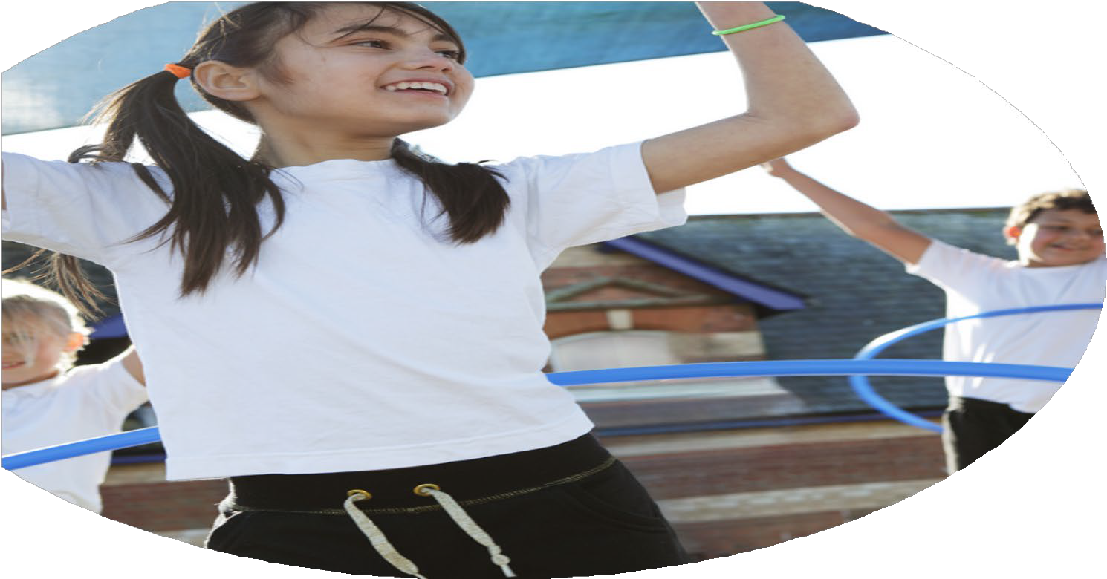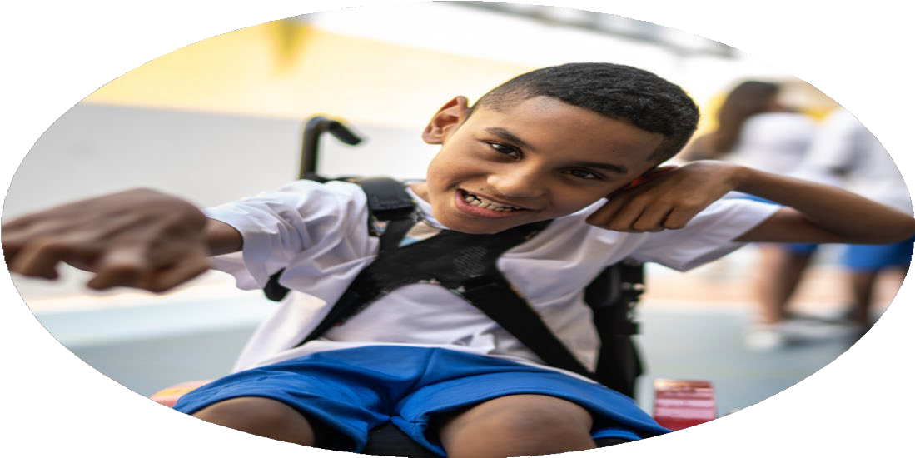

Evaluation Form

**Commissioned by**

**Created by**

Images courtesy of Youth Sport Trust

**PE Funding Evaluation Form**

 It is intended that this template should be used as preparation for the completion of the statutory digital reporting tool being introduced this academic year. You can upload data (including swimming) from this template onto this platform once it becomes accessible.

 Before you decide how you are going to use the funding for this academic year you should reflect and evaluate the impact of your use of the funding in 2023/24.

 All spending of the funding must conform with the terms outlined in the Conditions of Grant document.  The template is a working document that you can amend/update during the year.

 Based on your evaluation of last year’s funding you should decide what you intend to do this academic year, how you will do it, and what impact you expect it to have.

It is important that the funding is used effectively and based on your school’s needs.

 You must use the funding to make additional and sustainable improvements to the PE and sport in your school.  You must develop and add to the PESSPA activities that your school already offers.

*Summative digital reporting from June 2025 will continue to include swimming and water safety information therefore funding can be used to provide top-up lessons where necessary to ensure pupils meet national curriculum swimming requirements.*

**We recommend that you start by reflecting on the impact of current provision and reviewing your previous spend**

|  |  |  |  |
| --- | --- | --- | --- |
| What went well? | How do you know? | What didn’t go well? | How do you know? |
| * All children accessed an intra-school competition during the year as part of their units of work. All children had the opportunity to compete against their peers during our school sports day. * The residential for Year 4 was subsidised so that all of Year 4 were able to go on the residential to Malvern and take part in OAA style activities. * Year 4 children were provided with Bike ability training. * High percentage of children in Year 4 and some Year 3 children took part in inter-school competitions and festivals. * Updated Progression Map and Curriculum Map. * Sports Week * After-school club provision * Updated Playground Markings and Equipment | * PE Lead used subject lead time to review the curriculum and ensure intra-school competitions took place. Annual Sport Day took place and children showed enthusiasm during the event and after. Lots of children were proud about taking part and receiving a sticker. * All children went to the residential and were very enthusiastic about their experiences and showed a lot of enjoyment after the trip. * We equipped a large majority of our Year 4 cohort with the skills to ride their bike safely in the local area, whilst other children have learnt a new skill. We received a lot of positive feedback from parents about how their child was far more confident now to go out on their bikes. * Participations lists showed that 71.7% of Year 4 children took part in an inter-school competition and 17.5% of our Year 3’s went too. Children filled in enjoyment surveys at the end of the county competition and showed great enjoyment and levels of self-belief after competing. * Updated versions of both of these are in the subject lead folder. These have been discussed with staff and altered accordingly. * All children in the school were involved in alternative sports during sports week. This year we invited in a Bhangra dance teacher and we had some great feedback from parents. Particularly for children from similar cultures as parents fed back that they really enjoyed it. * Reception- 40% of the year group were able to participate in an after school club at some point in the year.   Year 1- 53.3% of the year group were able to participate in an after school club at some point in the year.  Year 2- 86.7% of the year group were able to participate in an after school club at some point in the year.  Year 3- 87.5% of the year group were able to participate in an after school club at some point in the year.  Year 4- 93.3% of the year group were able to participate in an after school club at some point in the year.  Therefore, the impact has been that high percentages of each year group have had the opportunity to take part in a sporting after school club this year. Children in Reception only get offered a club in the Summer term to allow them to settle into school life but there is always high interest and in Year 1, we had low uptake of clubs although they were offered a variety.   * Playground markings have allowed for children to play and enjoy lot’s of new games and breaktimes and lunchtimes ensuring that we are encouraging lots of children to be active during the day. | * Due to the SL being on Maternity leave, other equipment such as ‘Active Challenge Boards’ have not been utilized to further enhance the sporting opportunities during breaktimes and lunchtimes as well as they could have. * Not many staff accessed CPD opportunities. * Some year group’s after school clubs were not overly varied and so we would like to ensure that each year group have a variety of clubs going forward. * We would like to try and keep more records on how active children are at our school. Next year we want to look at keeping more of a record on how many children are accessing ‘active’ breaktime activities and getting more evidence on who are least active children are. * Our SEND and Pupil premium children didn’t visit any sporting events particularly aimed at these children and so we would like to ensure we offer these opportunities again next year. | * Pupil and Staff feedback * Pupil and Staff feedback * Subject Analysis * Subject Analysis * Subject Analysis |

|  |  |
| --- | --- |
| What are your plans for 2024/25? | How are you going to action and achieve these plans? |
| Intent | Implementation |
| * Now that the SL is back from maternity leave, we will re-introduce the use of ‘active challenge’ boards,with the help of the new Sports Crew next year in order to promote an additional 30 minutes of exercise during each school day. * Ensure that our new sports crew receive ‘play leader’ training to enable them to run activities for the younger children. As a part of this training, get them to think about how some of the different line markings could be used for games. * We would also like to put in place a system to be able to record who has been physically active during breaktimes in the form of hard data so that our evidence can be substantiated. * Continue with annual inspections for safety of equipment. * Continue to offer the bikeability training to the next cohort of Year 4s to continue to provide this sustainable skill that children can leave Finstall with for future active lives. * Continue with the subscription for the All Active Academy next year to allow children to continue to be able to take part in inter-school competitions. * We hope to take an even higher percentage of our Year 3 and 4 children to inter-school tournaments and festivals, including targeting our Pupil premium children and least active. We would also like to try and attend some of the KS1 sporting festivals to allow KS1 to participate in out of school sporting opportunities. * We want to record how many children participated in competitive sports and tournaments in the previous year and then record this again at the end of the year to see, in hard data, the impact of our efforts. * We want to provide our ECT teacher with the opportunity to go on the ECT PE training day that is provided by AAA. * We also hope to send more of our staff on CPD courses that are provided by the AAA. * To continue offering lots of opportunities to take part in an active club to every year group. We are hoping to provide some alternative sports too. We are hoping to ensure every year group above reception has a mixed variety of sports on offer throughout the year. We will also look to provide a club for our least active group, by talking to them in an attempt to cater for their interests. * We will continue to offer a Sports Week and try to include further opportunities to introduce children to alternative sports in the hope that more children will attend external clubs in the local area. We would also like to work towards building in some kind of house competition during this week. * We would like to record the number of children who participate in external clubs at the beginning of the year and then ask them again at the end of the year so that we can gain some hard data as evidence of the impact of our efforts. * We would like to source some coaches to support staff CPD in some of the areas where we have brought in new planning so that the staff can build their confidence watching specialised sport coaches teach our new planning and so that they may have opportunities to pick up new ideas on how to teach certain skills. By bringing in sports coaches, we hope that this will further improve the children’s learning experiences too as specialist teachers can often inspire young learners to want to continue sports they learn in schools outside of school in local community clubs. Coaches may also be able to signpost their clubs to encourage an increased uptake in extra-curricular sports. * We will continue to review the sports equipment utilizing the sports crew to help maintain the upkeep of resources and to ensure the children have adequate amounts of equipment that is safe to use, which will allow them to practise their sporting skills during lessons. * Continue to take as many children as possible to different events put on by the AAA to help enhance the sporting opportunities that we provide here at Finstall for all of our children, regardless of their sporting ability, gender, age, whether they have SEND or receive Pupil premium, etc. We would particularly like to ensure that we give opportunities to our SEND, Pupil premium and Least Active children to encourage these groups to be as active as possible during the school day but also to inspire them to want to take up extracurricular sporting opportunities too. * We will continue to offer this alternative, competitive sport to our Year 4 children. * We hope to be able to subsidize the Malvern trip again for this year’s cohort to ensure we make this experience accessible and affordable for all. * We will continue to try and provide the children in Years 3 and 4 the experience of doing their sports day on a proper athletics track as the children seem to thrive on the experience. It also provides a strong link with the local sports centre and might inspire our children to take up some of the activities that are provided by it, particularly athletics. | * Have regular sports crew meetings to decide on activities and how often they will be changed. * Book in a date with the AAA to arrange for this. * Devise a way of recording how many children are accessing the ‘active challenges’ that are shared with them at breaktimes or lunchtimes. * Book in a date with the company we usually use to ensure the equipment is checked during this year. After the report comes back, ensure any safety issues are addressed to ensure our equipment is safe for the children to use. * Book a date in with the company we have used previously to ensure this happens at some point in the year. * Attend the staff meetings that the AAA provide to keep up to date with events that are happening throughout the year and sign up to the ones that we feel will benefit our children the best. * Plan in advance, using the AAA calendar the events that we are able to attend so that we can ensure we can take children to as many events as possible during the year. Sign up to the KS1 events as early as possible to avoid them being oversubscribed. * Add this on to the club spreadsheet that has been created to record in- school and outside of school clubs. * When the ECT course becomes available, book her on. * Offer all of the CPD courses that are provided by the AAA to the staff in staff meetings. We will also analyse our staff questionnaire to see if there is any areas where staff confidence is low and suggest courses that are available wherever possible. * Ensure that we have clubs going on every day after school for each year group. Ensure that Reception children can offered a club in the Summer term. Source alternative clubs to provide a wide range of different sports. Once we have found which of our children are ‘least active’ have a meeting with them to find out which sports they would be interested in taking part in and try to arrange for a sport that most would get involve in. * Plan ahead and source local clubs that might be able to attend during our school sports week. We will then analyse our clubs spreadsheet to monitor uptake of new sports. Meet with sports crew to organise a competition that we could run throughout every year group during the sports week. * Set up the ‘club’ spreadsheet for each class to record what clubs have gone on during this year for each class and who has attended. Also have on this spreadsheet what clubs the children have at the start of the year and re-record this at the end of the year. * Link with local clubs to organize whether CPD opportunities could take place based on a sport that staff haven’t had training in for a while to give confidence to the staff but also ensure that activities are progressive for their age and develop the curriculum further. * Regularly check equipment during sports crew meetings. * Plan in advance, using the AAA calendar the events that we are able to attend so that we can ensure we can take children to as many events as possible during the year. Sign up to the KS1 events as early as possible to avoid them being oversubscribed. Introduce breaktime activities ran by our sports crew and include some targeted activities for certain groups of children. We will also be trying to provide rewards for children who participate in activities too. * Sign up to take part in the bell-boating regatta organized with the Bromsgrove cluster. * Assess the need of subsidizing nearer to the payment time. * Book a date for this to happen in advance. |

|  |  |
| --- | --- |
| What impact/intended impact/sustainability are you  expecting? | How will you know? What **evidence** do you have or  expect to have? |
| * More children active at breaktimes/lunch and more motivated to do something active promoting healthy lifestyles for their futures. * Introduction of new games for children to play at lunchtimes/ breaktimes. Leaders on the playground leading activities. Children’s bank of games to play enhanced. * Lots of equipment available for children to use during playtimes/PE lessons. A lot of this equipment will be used for years to come. * More children able to confidently ride a bike and more who know key road safety rules before leaving Finstall First School. These are skills that the children will carry for life. * Lots of children taking part in inter-school festivals/ competitions. Inspiring children to want to continue sports in the future. * Staff confidence boosted and future provision enhanced.      * Lots of children participating in active clubs after school. This will then hopefully inspire future uptake to maintain healthy lifestyles. * Children who are seen as ‘least active’ taking part in trips/ clubs/ activities at breaktimes and lunchtimes provided by us as a school. This will hopefully inspire them to keep active and enjoy being active. * Children introduced to different sports in school sports week and encouraged to look into local clubs that provide these if enjoyed. Leaflets given out at the end of sessions to encourage this. This could then promote life-long interest in a sport/ being active. * All Year 4 children to have experienced a residential and to have tried new skills and built on their personal development whilst on this experience. * Year 3 and 4 children to enjoy an intra-school competition and to have had the opportunity to experience athletics on an ‘official’ track. This could lead to inspiring children to want to pursue athletics outside of school or to be active in the future. | * We will have a record sheet of how many children have been spotted by leaders being ‘active’ at breaks and lunches. * We will conduct pupil interviews which will be recorded to see their experiences and whether they feel they are active and what games they like to play. * We will conduct pupil interviews which will be recorded to see if they enjoy playing with the equipment provided. We will also get staff to fill out a staff questionnaire to ensure they have the equipment they feel they need to undertake high quality lessons with sufficient equipment to the best of their ability. * We will have a record of which children took part in the bike ability and who achieved the training. * We will have competition lists to show which children have taken part in competitions throughout the year. We will also conduct pupil interviews which will be recorded to get an idea of the children’s experiences when taking part in festivals/competitions. We will also review how many children have taken part at the end of the year before completing the sports premium review.      * We will complete a staff questionnaire to elicit their confidence teaching the lessons they provide at different points in the year. Evidence will also be in high quality plans and CPD records. * We will have a record of all the clubs each individual child has been involved in and how many children have accessed a club throughout the year on a spreadsheet. We will do a clubs review at the end of the year too. The spreadsheet will also allow us to see if any of the children have taken up any further clubs outside of school during the year. * We will have a list of children who we identified at the start of the year as ‘least active’. We will then be able to monitor if these children take up any of the activities offered to them throughout the year via club lists, competition lists etc. Certain trips and activities provided in school time will target these groups and we will also use pupil voice to help engagement in activity. * On the clubs spreadsheet we will be able to identify if any children have taken up a club. We will also conduct pupil interviews where we will ask questions about whether they felt inspired during sports week to take up any of the sports. We will have a timetable that will include all the sports the different year groups have taken part in. * We will have a trip list that states how many children took part in the trip. We will also conduct a pupil voice to elicit the positive beneficial experiences that children gained from this opportunities. * We will have a sports day time table with all of the children who took part in the competition. We will also have the clubs spreadsheet that might indicate whether any of the children were inspired to take up athletics. We will also conduct a pupil voice which will include questions on sports day to find out children’s experiences. |

|  |  |
| --- | --- |
| What **impact/sustainability** have you seen? | What **evidence** do you have? |
|  |  |