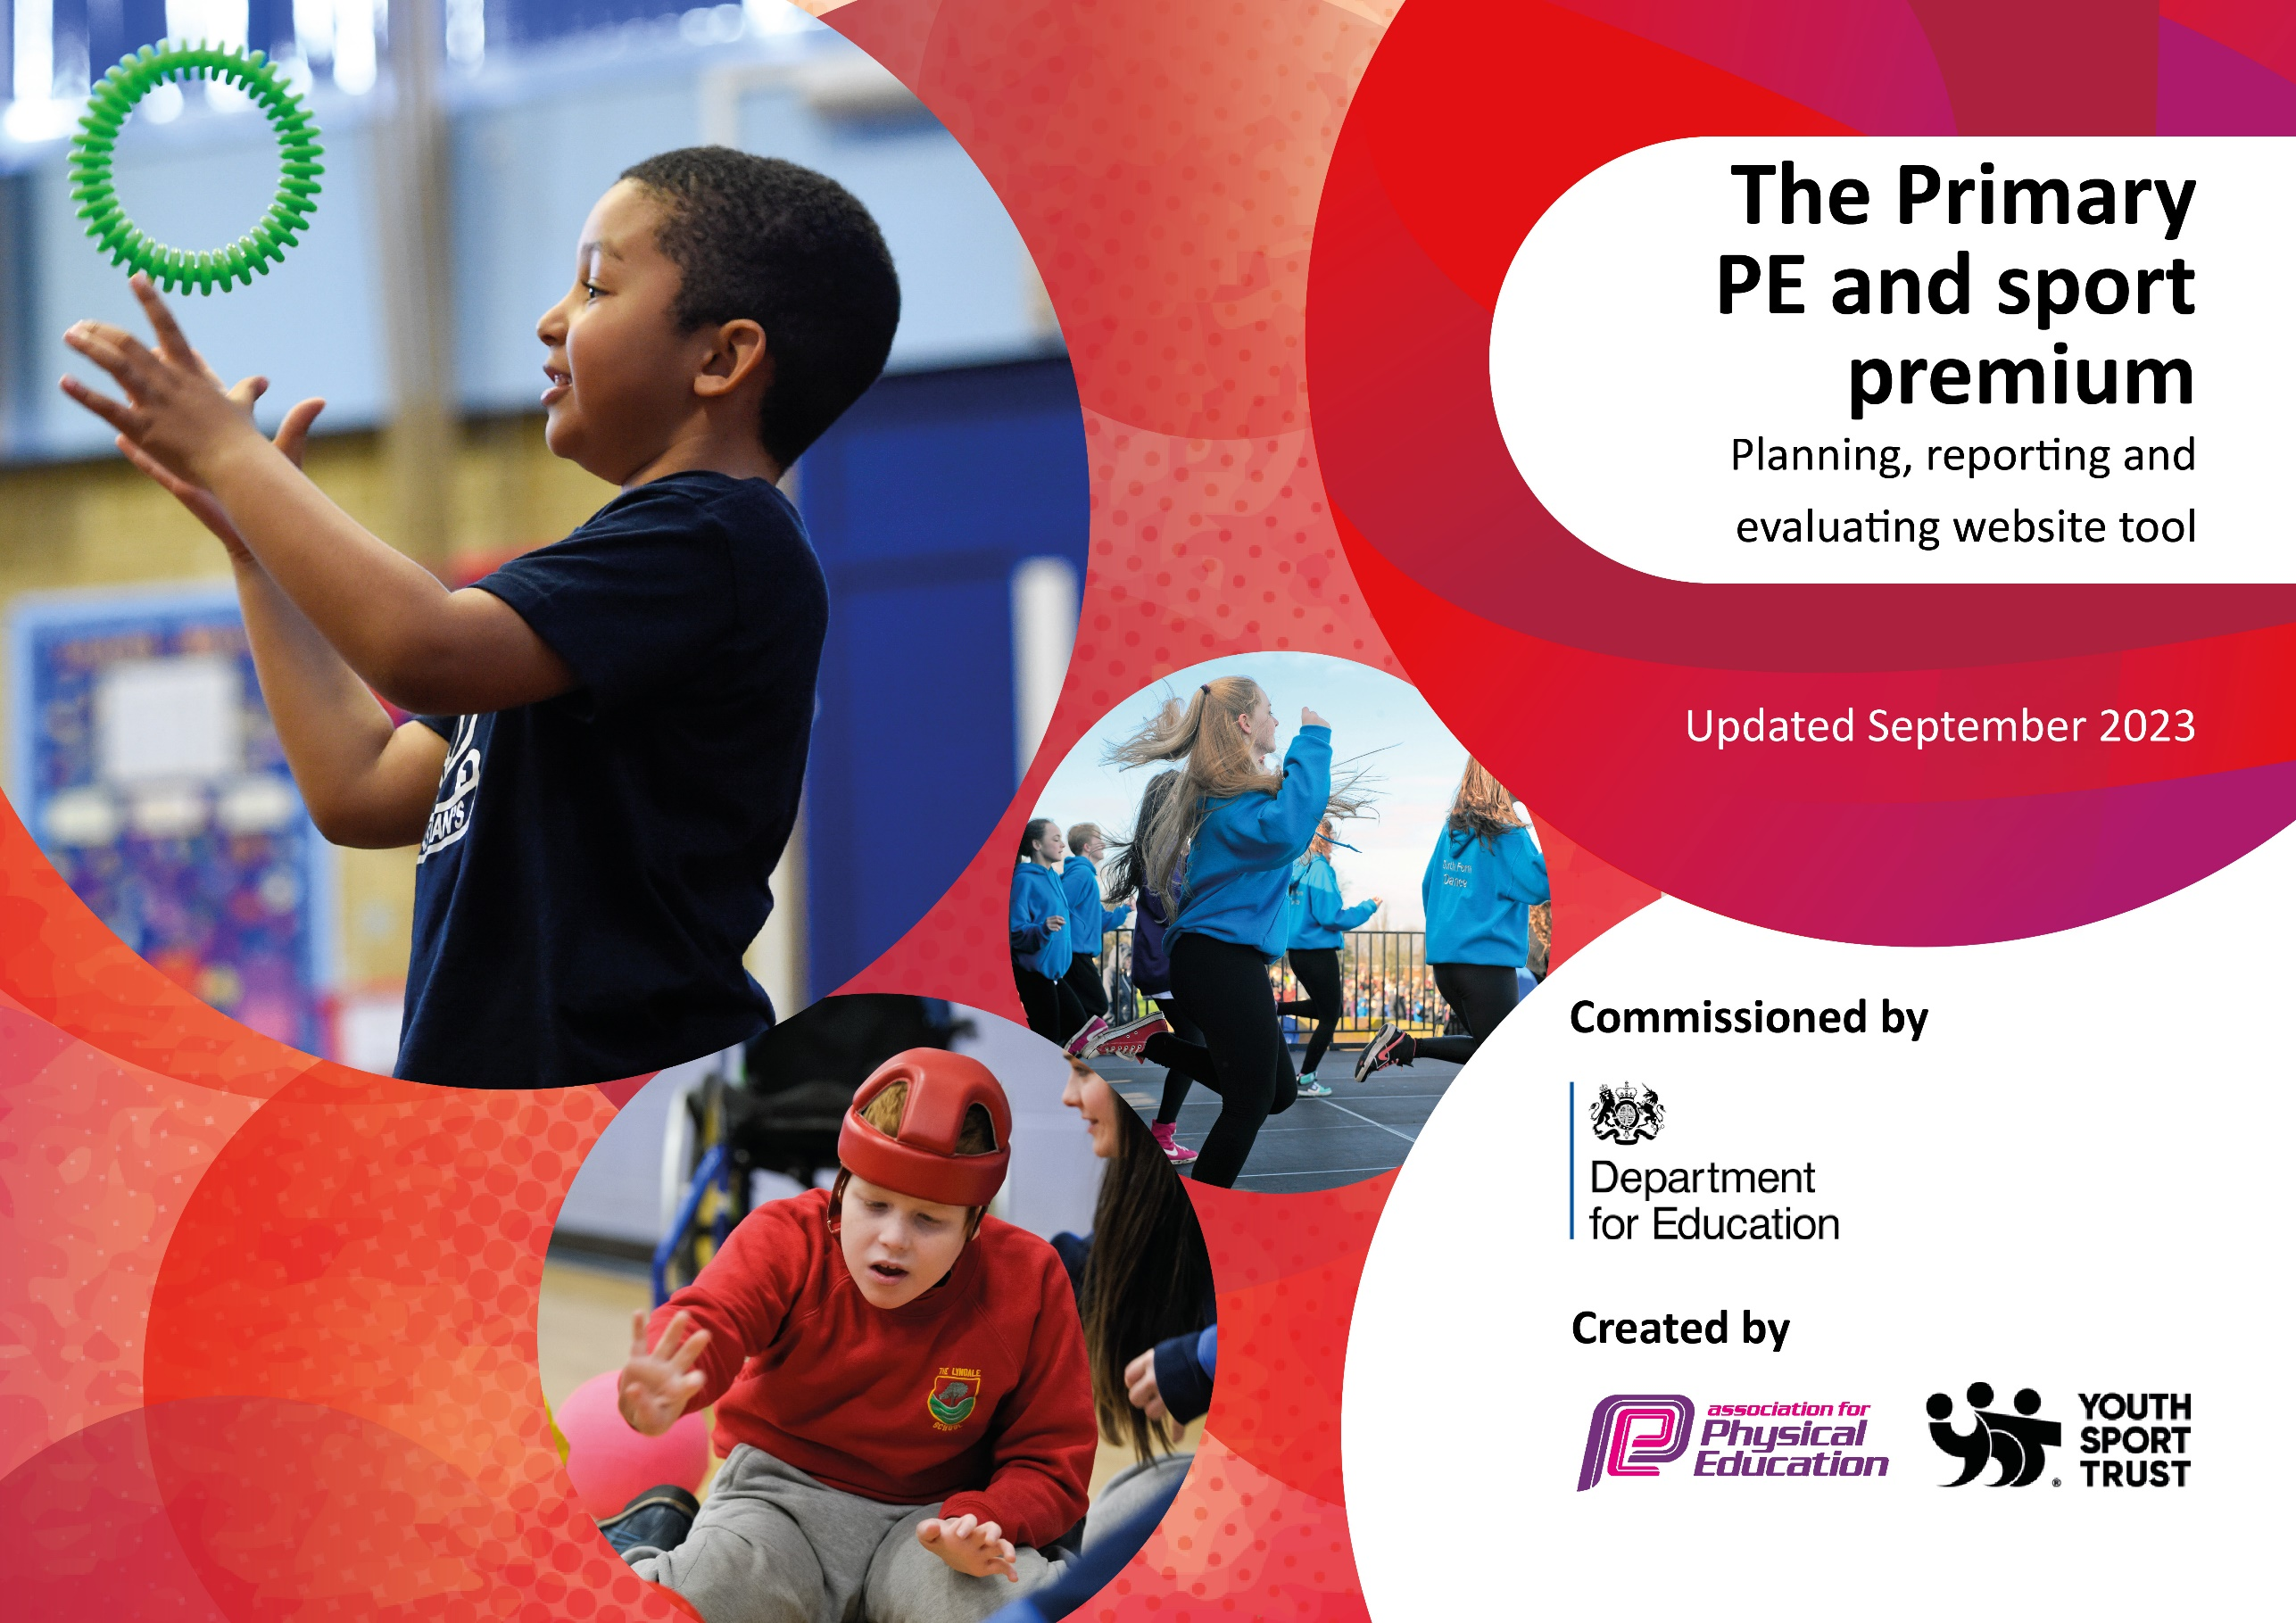
400

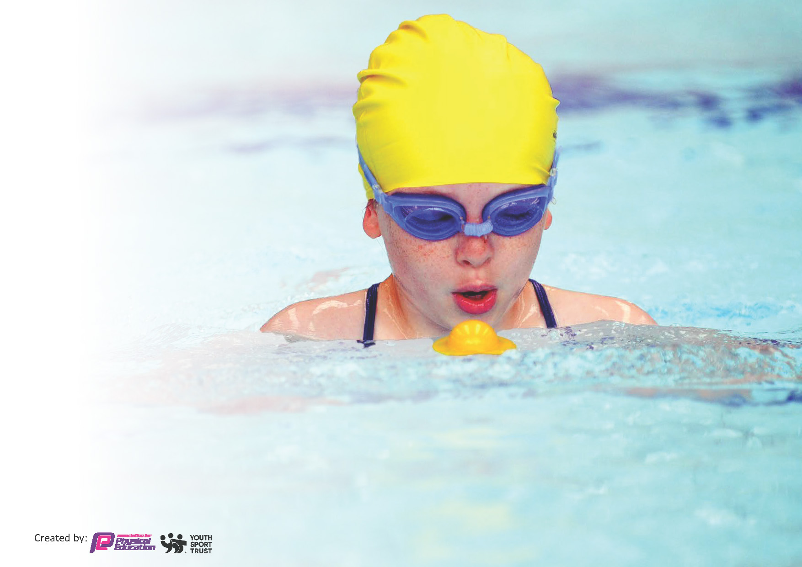
This template can be used for multiple purposes:
by:
- It enables schools to effectively plan their use of the Primary PE and sport premium
- It helps schools to meet the requirements (as set out in guidance) to publish information on their Primary PE and sport premium
- It will be an effective document to support Ofsted inspections enabling schools to evidence progress in Physical Education (PE) and evidence swimming attainment, which forms part of the PE National Curriculum. We would recommend schools consider
the Intent, Implementation and Impact of any spend, as examined within the Education Inspection Framework.

It is important that your grant is used effectively and based on school need.

Schools must use the funding to make additional and sustainable
improvements to the quality of the PE, School Sport and Physical Activity (PESSPA)
they offer. This means that you should use the Primary PE and sport premium to:

- Build capacity and capability within the school to ensure that improvements made now will benefit pupils joining the school in future years
- Develop or add to the PESSPA activities that your school already offers.

The Primary PE and sport premium should not be used to fund capital spend projects; the school’s core budget should fund these. Further detail on capital expenditure can be found in the updated Primary PE and sport premium guidance.

The Primary PE and sport premium guidance, outlines 5 key priorities that funding should be used towards. It is not

necessary that spending has to meet all the key priorities, you should select the priorities that you aim to use any funding towards.

Although completing this template is not a requirement for schools, schools are required to publish details of how they spend this funding. Schools must also outline what the impact this funding has had on pupils’ PE and sport participation and attainment and how any spending will be sustainable in the future. All funding must be spent by 31st July 2024.

The Department for Education has worked closely with the Association for Physical Education (afPE) and the Youth Sport Trust (YST) to develop this template and encourages schools to use it. This template is an effective way of meeting the reporting requirements of the Primary PE and sport premium.
Review of last year’s spend and key achievements (2022/2023)

We recommend you start by reflecting on the impact of current provision and reviewing your previous spend.

Activity/Action | Impact | Comments
Provide outdoor gym and fitness equipment around the outside of the running track on the field.  Boards to display “Break time Challenges” promoting being ‘active’.  Wide range of equipment and resources available to children at break and lunch times including bouldering wall, sensory garden, adventure playground, running track as well as a wide range of play equipment.  Annual Inspection of outdoor play equipment.  Year 4 children to participate in Bike-Ability to ensure they can ride their bikes safely.  Subscription to All Active Academy who provide a range of sporting opportunities.  After-School Clubs to allow more children to be active throughout the day.  A range of sports provided during Sports Week to bring awareness of the benefits of sport and spark interest in a sport they could participate in outside of school.  Disadvantaged (PP) children to be taken to a Pupil Premium Event run by the All Active Academy.  Continue to have strong links with cluster schools through the meetings provided in All Active Academy. PE Lead networks with other PE Leads to share ideas, developments and areas for improvement.  Update and refine the PE skills Progression Map.  Use CPD hours from the All Active Academy to update PE units in Years 2 and Year 4 so they are in line with other year groups.  To subscribe to Jigsaw – The Mindful Approach to teaching PSHE.  Permanent pathway to be laid through the Sensory Garden to provide all-year round access. Repair of posts.  Analyse the PE Assessment Data from this year to monitor the impact of the ‘Deeper Understanding’ statements and to identify any inconsistencies in the data.  Teacher questionnaire given out at the start of the year to gain an understanding of any CPD requirements to continue to develop staff’s subject knowledge and confidence.  Staff provided with training on how to use the new planning provided for Year 2 multi-skills lessons.  To identify gaps in resources/ equipment and purchase according to priority.  Each year group has 2-hour slots of PE each week.  Use of a playground rota to ensure all children have regular access to playground equipment such as the adventure playground, bouldering wall, running track, sensory garden, etc.  A large number of children, particularly Years 3 and 4, to take part in a variety of inter-school competitions.  All of the Year 4 children to be given the opportunity to learn some street dance routines in the Summer Term by an external coach.  All the Year 4 children visit the Malvern Hills Boundless Outdoor centre where they are able to take part in OAA activities.  All Year 4 children to go on a ‘Bell boating Journey’ along a local canal.  Children in Years 3 and 4 who cannot swim 25 metres by the end of the Spring Term to attend a further 10 sessions funded by the School.  All children to be given the chance to compete in a Sports Day – Lower School on the School Field and Upper School at the Ryland Centre Athletics Track.  Level 0 competitions offered by Playleaders as part of their challenges set at breaktimes and lunchtimes. | Impact will be measurable after the equipment is installed in July / August 2023.  Noticeboards purchased and populated with “Break time Challenges,” which encouraged children to attempt the challenges and record their personal bests. Children more aware of how they have improved their performance against the various challenges  Higher % of children are engaged in physical activity, including challenges, at break and lunch times.  Play equipment is safe for children to use.  All Yr 4 children took part in bike-ability training so their bikes were safe and they could ride them safely  Children have access to a range of competitions and different sports through AAA and staff have increased CPD opportunities  Children have had access to the following After School clubs:  Football – Yrs 3, 4  Gymnastics – Yrs 1, 4  Irish Dancing – Yrs 1, 2  Hockey – Year 3  Tennis – Year 2  Tag Rugby – Year 4  Golf – Year 3  Bell-boating – Year 4  This has encouraged children to continue with such sports in external clubs.  Activities such as Gymnastics, Martial Arts, Irish Dancing, Yoga and Basketball were provided for children who didn’t access these as after school clubs. This has encouraged children to continue with such sports in external clubs  Disadvantaged children attended PP event, run by AAA, which exposed them to a range of sports to encourage them to continue with these outside school.  During monitoring of PE, and the PE curriculum in particular, in the Spring Term, areas for improvement were identified.  PE Lead went on maternity leave at end of Spring Term 2023. Non-specialist, in temporary role, has done her best to manage the subject since taking over. Did a particularly good job in organising School Sports Week and both Lower and Upper School Sports Days.  Some improvements made to Progression Map but work will need to be completed to further improve the PE Skills Progression Map.  Not completed by SL prior to going on maternity leave and will need to be carried over to next year.  Children say they enjoy the calm nature of PSHE lessons, which help them to understand themselves and how to stay healthy, both physically and mentally.  Path laid so children are able to access this all year round. Children enjoy using this at break / lunch times – helps with good well-being.  High % of children attain at least a good level against the PE objectives and a reasonably high % also achieve a higher / deeper level. Slight inconsistencies of understanding of staff judging deeper / higher level of understanding addressed by providing support to individual staff.  CPD requirements of staff identified at beginning of year.  Following training provided by SL, Year 2 staff know how to use the new planning for Year 2 multi-skills lessons.  Additional equipment purchased as identified to enable the effective delivery of the curriculum and to provide for children at break and lunch times.  High % of children achieve a good level in PE and a reasonably high % achieve a higher / deeper level. Children say they enjoy their PE lessons and understand the benefits that regular exercise and involvement in sports and activities bring. High % of children take part in physical activity at break and lunch time, in after school clubs and outside School.  Tournaments included:  Football – Yr 4  Hockey – Year 4  Tennis – Year 3  Tag Rugby – Year 4  Golf – Year 3  Bell-boating – Year 4  Pupil Premium – Mixed ages  Children have enjoyed them and have experienced success and disappointment with equally high degrees of sportsmanship.  All Year 4 children received a course of lessons in Street Dance, as part of the Dance aspect of their PE Curriculum.  School supplemented the trip to Malvern and the bell-boating journey so that all children could access them, irrespective of their financial situation. All children accessed a range of OAA activities that they would not normally able to access.  Further 10 lessons provided for weaker swimmers to enable a few more to be able to swim 25 metres by the end of the year.  All children took part in a Sports Day and enjoyed the experience. Children were taught to be good sports and were rewarded with stickers for top 3 finishes or for taking part.  Children encouraged to compete with their personal bests in challenges set at break and lunch times. | Teach children how to use the equipment as part of a circuit around the track. The equipment should provide different fitness activities for many years to come. Children are effectively using the equipment  Continue to access. Some reintroduction may be required for 2023/2024 Need to look into how this can be recorded in a user friendly way that does not impact on classroom time.  Continue to ensure plentiful equipment is available to the children and that challenges are refreshed and celebrated to encourage continued use. Annual check to be completed.  Continue to participate in Bike-ability scheme with year 4 children and maybe extend to Yr R with balance bikes.  We will continue to work in partnership with AAA to access high-quality support and advice, staff CPD and opportunities for children to access competitions and different sports.  Continue to offer children a range of after school clubs so that many children have access to physical activity after school and they are encouraged to continue with physical activity outside of school as part of a healthy life.  Continue to offer new and alternative sports to children during School Sports Week to encourage them to participate in external clubs outside of School.  Through AAA, continue to take PP children to such events in future to encourage them to continue with participation in sport outside School.  Further work needs to be completed on improving and refining areas of the PE Curriculum, as identified in monitoring that took place during the Spring Term 2023.  Increase monitoring activities for PE during SL release time – lesson visits, pupil voice, planning scrutiny, quality of assessment, etc.  Temporary SL to receive support from Senior Leaders and the AAA to further improve the PE Skills Progression Map and certain PE Units in Years 2 and 4.  Continue to use Jigsaw for the PSHE curriculum. Annual online subscription will improve access to planning and wider range of updated resources.  Continue to encourage use of Sensory Garden to develop pupils’ well-being and mental health.  Through ongoing monitoring, continue to check that staff have a good understanding of how to judge higher / deeper levels against the PE objectives.  SL to continue to check with staff regarding CPD requirements. Also use Lesson Visits to check that curriculum is being delivered as designed.  Check that staff (CTs and TAs), particularly those new to Year 2, are delivering lessons as expected and are aware of expectations of PE curriculum in Year 2 and provide any further support as required.  Continue to purchase equipment and resources as required.  Ensure that children continue to access at least 2 hours of PE on the curriculum each week.  Continue to promote the benefits of children taking part in regular exercise and being involved in sports and activities at break and lunch times, during after school clubs and outside School.  Children to continue to participate in inter-School competitive sport, partly through our involvement in AAA.  Continue to expose children to different forms of dance, from different cultures, within the PE curriculum, as long as the sequence of learning is not disrupted.  Continue to ensure that the residential trip to Malvern and the bell-boating journey are accessible for all children.  Continue to offer this in the Summer Term for children in Years 3 and 4.  Continue to encourage competitive sport and the expected behaviours that accompany this form of sport. Extend competitions between houses for different sports in future.  Ensure that challenges are refreshed and celebrated to encourage continued use and also include new outdoor gym equipment.

Key priorities and Planning
This planning template will allow schools to accurately plan their spending.

Action – what are you planning to do | Who does this action impact? | Key indicator to meet | Impacts and how sustainability will be achieved? | Cost linked to the action
Provide a variety of opportunities for children to take part in regular physical activity. Highlight the importance of regular physical especially during break times and lunch times by continuing to provide challenges on the new boards put up around the playground  Provide a variety of opportunities for children to take part in regular physical activity. Highlight the importance of regular physical activity by promoting after school clubs in different year groups throughout the year.  Increase awareness of the sports available both inside and outside school and promote sport in general to ignite interest in taking up a sport.  Promote well-being and relaxation time as an additional activity during breaktimes so that children can find out information about Sports and improve their mental well-being.  Continue work on improving and refining the curriculum to ensure it is providing a wide range of sports in a progressive way (to deepen skills and understanding so children get better), that it is being taught to a high standard and that children are being provided with at least 2 hours of PE lessons a week.  Continue to encourage competitive sport (for all pupils) and the expected behaviors that accompany this form of sport. Extend competitions between houses for different sports in future.  Continue to ensure that the residential trip to Malvern is accessible for all children.  Continue to participate in Bike-ability scheme with year 4 children and maybe extend to Yr R with balance bikes.  Children in Years 3 and 4 who cannot swim 25 metres by the end of the Spring Term to attend a further 10 sessions funded by Sport Premium. | Lunchtime supervisors / teaching staff  Sports Crew- they will support and encourage children to take part in activities.  Pupils – as they will take part.  Pupils – as they will take part.  The community clubs as some children may take up this sport, outside of School, after taking part in the after school club.  Pupils – as they will take part.  Staff- they may pick up knowledge and skills from working with experts in sport.  The community clubs as some children may take their sport after taking part in the after school club.  Pupils – as they will take part.  Staff- improve their understanding of the curriculum and how to teach it.  Children - outcomes will improve year on year.  Children- they will be involved in competitions  Children in Year 4.  Children in Year 4.  Children in Year 3 and 4. | Key indicator 2 -The engagement of all pupils in regular physical activity.  Key indicator 3 The profile of PE and Sport is raised across the school as a tool for whole school development  Key indicator 4: Broader experience of a range of sports and activities offered to all pupils  Key indicator 2 -The engagement of all pupils in regular physical activity.  Key indicator 3 The profile of PE and Sport is raised across the school as a tool for whole school development  Key indicator 4: Broader experience of a range of sports and activities offered to all pupils.  Key Indicator 1: Increased confidence, knowledge and skills of all staff in teaching PE and sport  Key indicator 2 -The engagement of all pupils in regular physical activity.  Key indicator 3 The profile of PE and Sport is raised across the school as a tool for whole school development  Key indicator 4: Broader experience of a range of sports  Key indicator 2 -The engagement of all pupils in regular physical activity.  Key indicator 3 The profile of PE and Sport is raised across the school as a tool for whole school development  Key indicator 4: Broader experience of a range of sports  Key Indicator 1: Increased confidence, knowledge and skills of all staff in teaching PE and sport  Key indicator 2 -The engagement of all pupils in regular physical activity.  Key indicator 3 The profile of PE and Sport is raised across the school as a tool for whole school development  Key indicator 4: Broader experience of a range of sports  Key indicator 4: Broader experience of a range of sports  Key indicator 5- Increased participation in competitive sport.  Key indicator 4: Broader experience of a range of sports  Key indicator 2 -The engagement of all pupils in regular physical activity.  Key indicator 3 The profile of PE and Sport is raised across the school as a tool for whole school development  Key indicator 4: Broader experience of a range of sports  Key indicator 3 The profile of PE and Sport is raised across the school as a tool for whole school development  Key indicator 4: Broader experience of a range of sports | More pupils meeting their daily physical activity goal, more pupils encouraged to take part in sport activities at playtime and lunchtimes.  - Ensure that equipment is kept well-maintained and plentiful for the children to use to allow for continued use throughout the year and beyond.  - Re-do the playground markings so that they are clear and engaging for the children to play on during breaktimes to allow for continued use throughout the year and beyond.  - More lunchtime staff trained on how to support children on the new equipment around school so that they can support children every lunchtime all year.  - Sports leaders given a responsibility to encourage others to take up the activities on the boards on playground / sensory garden so that they can support children regularly at breaktimes and lunchtimes throughout the year. They can then train the next lot of children for the following year.  More pupils meeting their daily physical activity goal, more pupils encouraged to take part in sport after school. Children to take part in a range of different clubs provided by outside clubs. Each year group offered a club at different points in the year. Clubs accessible to all- including girls and boys.  Children provided with additional sporting opportunities during School Sports week that the children may not have taken part in previously. Link with local clubs to promote what children can take part in outside of school which may lead to an increase in the engagement of pupils in regular physical activity.  Bromsgrove Gymnastics Club invited back in as Gymnastics is always a sport that staff have less confidence in so that the staff may pick up some knowledge/ skills from observing the sessions they provide for the children.  Learning opportunities provided around the European Football Championships, Wimbledon and Olympics to promote sport as a whole that will hopefully inspire children to get active or take up a new sport.  Provide the Year 4 children with a bell-boating journey during school time and then offer after school club that is accessible for all to prepare some of them for an inter-school competition.  Children to have the opportunity to relax in quiet spaces and read at break times (Books on Reading Trolleys). Include some books about different sports to inspire the children to participate in active sports that are available to play at breaktimes and lunchtimes. This will then lead to more children being physically active both at school and possibly at home.  Children to have the opportunity to take part in yoga and mindfulness challenges promoted on the ‘Active Challenge’ board in the sensory garden. Yoga may be an activity that children have not taken part in before broadening their experiences of a range of sports but also raising the profile of PE to all children and how it can benefit your physical and mental well-being.  Continue to work in partnership with AAA to access high-quality support and advice, along with staff CPD, so that we can improve and refine our curriculum and how it is delivered.  Further work needs to be completed on improving and refining areas of the PE Curriculum, as identified in monitoring that took place during the Spring Term 2023.  Increase monitoring activities for PE during SL release time – lesson visits, pupil voice, planning scrutiny, quality of assessment, etc.  Temporary SL to receive support from Senior Leaders and the AAA to further improve the PE Skills of staff, to develop the Progression Map and certain PE Units (in Years 2 and 4).  High % of children take part in inter-school competitions in Year 3 and 4 to enhance their sporting experiences, understanding and skills to deal with competitive situations.  To continue to run sports day events to offer all the children in school the chance to take part in intra-school competition.  Through AAA, continue to take PP children to events to expose them to competitive sport and to encourage them to continue with participation in sport outside School.  Build in termly intra-school sport competitions between houses. Use the sport leaders to plan, support competitions and give rewards out.  All children in Year 4 will have the opportunity to go to Malvern and experience some of the sports on offer such as rock climbing, problem solving, orienteering etc.  All children in Year 4 have access to the bike ability training to encourage them to bike to school, use their bikes outside of school as a source of good exercise and it is a skill they can use for the rest of their life.  Children in Year R given a head start in helping them to learn to ride a bike safely.  All children given as much experience as possible to achieve the 25m before leaving Finstall, to help them to achieve the national curriculum expectation by the end of Year 6 and also to equip them for life if ever entering water. | Playtime equipment maintained and replenished if needed - £3800  Playground Markings - £3,250  Training for Lunchtime Staff  PE Co-Ordinator time (£615 across the year) to meet with Sports Crew to discuss what challenges to give the children and how to encourage children to do it. Also discuss a system where we can record children who are taking part in it.  Up to £3000 for subsidising after school clubs throughout the year.  School Sports Week £800  £700.00 for bell-boating trip expenditure.  £600 on equipment / books.  AAA subscription - £2,124  Regular Subject Coordinator time, as stated above, plus additional release time as required – up to £2,000.  £1,700- For staff cover, transport to tournaments etc.  Track hire / Rewards for Sports Day - £130  £1,000  £300  Cost of additional swimming sessions - £1300.00

Key achievements 2023-2024
This template will be completed at the end of the academic year and will showcase the key achievements schools have made with their Primary PE and Sport Premium spending.

Activity/Action | Impact | Final Cost | Comments
Wide range of equipment and resources available to children at break and lunch times including bouldering wall, sensory garden, adventure playground, running track, gym equipment as well as a wide range of play equipment.  Annual Inspection of indoor and outdoor PE / play equipment.  Year 4 children to participate in Bike-Ability to ensure they can ride their bikes safely.  Subscription to All Active Academy who provide a range of sporting opportunities and support for Subject Leads.  Continue to have strong links with cluster schools through the meetings provided in All Active Academy. PE Lead networks with other PE Leads to share ideas, developments and areas for improvement.  After-School Clubs to allow more children to be active throughout the day.  A range of sports provided during Sports Week to bring awareness of the benefits of sport and spark interest in a sport they could participate in outside of school.  Update and refine the PE skills Progression Map.  To identify gaps in resources / equipment and purchase according to priority.  Each year group has 2 x 1 hour slots of PE each week.  A playground rota is also used to ensure all children have regular access to playground equipment such as the adventure playground, bouldering wall, running track, sensory garden, etc.  A large number of children, particularly in Years 3 and 4, to take part in a variety of inter-school competitions.  All Year 4 children to go on a ‘Bell boating Journey’ along a local canal and to be offered the opportunity to take part in an after-school bell boating club.  All children in Year 4 to have the opportunity to go on the Malvern Hills residential. We have subsidised each child by £19 to make the opportunity accessible for all.  Children in Years 3 and 4 who cannot swim 25 metres by the end of the Spring Term to attend a further 10 sessions funded by the School.  All children to be given the chance to compete in a Sports Day – Lower School on the School Field and Upper School at the Ryland Centre Athletics Track. | Children have had a wider selection of equipment to use during their breaktimes. The impact of this is that more of them have chosen to be active during these times. Teachers and dinner staff have been able to organise more structured activities, following on from their play leader training, for the children to take part in - using the variety of equipment. As a result, a larger number of children have become more active.  We have also purchased some books linked to different sports, fiction and non-fiction that the children may chose to pick up at breaktime or lunchtime. The impact of this is that all the children who are out at breaktimes and lunchtimes have the opportunity to have some relaxation or quiet time, reading at breaktimes to promote their mental well-being. It also means any of the children who chose to do this have been enriched with lots of knowledge and facts about sport or have been inspired.  Our playground markings needed repainting as the children were struggling to see some of the sports pitches and games they use to be ‘active’ at break times. The impact of having them resprayed will be that more children are encouraged to use the markings to make games to play during their break times. This will help more children to be involved in active games, thereby promoting the active 60 mins.  PE / play equipment has been inspected and deemed safe for children to use with some recommendations on how to improve its condition further. These improvements were then carried out to allow for large numbers of children to be able to continue to use the equipment to be active.  All children in Year 4 were given the opportunity to do some form of Bike training whether it was the Bikeability Level 1 course or the learn to ride course. 47 children out of year 4 undertook the Bikeability Level 1 course which teaches children how to safely ride their bike. 9 children completed a separate course that helped them to learn how to ride a bike without stabilizers. The impact of this is that we have now equipped a large majority of our Year 4 cohort with the skills to ride their bike safely in the local area, whilst other children have learnt a new skill. We received a lot of positive feedback from parents about how their child was far more confident now to go out on their bikes.  Children have had access to a range of competitions and different sports through AAA so the impact of this is that a large percentage of children in Year 4 have participated in an interschool competition and staff have had increased CPD opportunities. One Year 3 team also qualified for the Summer Sports games. The impact on the children’s sense of pride and achievement was greatly increased and the children were so proud to be representing our district at a higher level. They also won an award for ‘Self-belief’ at the Summer Games, which we were able to celebrate with the rest of the school and promote the School Games Values. This helped to instill these positive qualities in other children in the school and to aspire to be like them. Some of the children who came with us to this competition had also stated how they have now asked their parents whether they can look into golf lessons, which is the sport they were competing in.  Temporary SL and SL, when she returned from maternity leave, have also received valuable support from attending network meetings and CPD provided by AAA.  They also obtained details about the range of sporting tournaments the children could be a part of and received advice about reporting their work, using the Action plan template. When Mrs Law returned from maternity leave, she attended the Spring and Summer meetings where she was able to gain contacts for School Sports Week and network with other PE leads to gain ideas on how to use future funding. The impact of being a part of the AAA has been that a high percentage of Year 4 children and some Year 3 children have had the opportunity to take part in festivals and tournaments. Staff have also been upskilled when gaining further ideas on how to direct our funding for different groups of children ready for next year.  Children have had access to the following After School clubs:  Football – Years 2, 3, 4  Gymnastics – Year 1,  Irish Dancing – Years 1, 2, 3 and 4  Tennis – Year 4  Tag Rugby – Year 4  Bell-boating – Year 4  Dance- Reception, Year 3  Zumba- Years 1, 3 and 4  Basketball- Year 2  This has encouraged children to continue with such sports in clubs outside of School and has helped children to meet their 30 active minutes outside of school and 60 minutes in school.  Reception- 40% of the year group were able to participate in an after school club at some point in the year.  Year 1- 53.3% of the year group were able to participate in an after school club at some point in the year.  Year 2- 86.7% of the year group were able to participate in an after school club at some point in the year.  Year 3- 87.5% of the year group were able to participate in an after school club at some point in the year.  Year 4- 93.3% of the year group were able to participate in an after school club at some point in the year.  Therefore, the impact has been that high percentages of each year group have had the opportunity to take part in a sporting after school club this year.  Activities such as Gymnastics, Martial Arts and Bhangra dancing were provided for children during our School Sports Week. This provided them with opportunities to take part in alternative sports/ activities that we do not provide in the curriculum, in the hope that it would inspire our young children to take part in these sorts of clubs outside of school. The impact of this was that during pupil voice conversations, a high percentage of the children said that they had enjoyed these additional sports and some were positive in trying to take up gymnastics or martial arts in particular.  During the week, we also got all of the children to take part in a Sports Week Homework, which was based around the European Football Championships 2024. This helped to inspire the children to watch the event and also be active at home. The children who completed the homework were then put into a prize draw and each class winner received a Euro 2024 football to help promote being active at home. Lots of children across the school completed this homework.  The PE coordinator has been given time to reflect on this document and make alterations to the curriculum to ensure that children in each year group are showing maximum progression in each of the sports / activities that they are taught. In some areas, new planning has been sourced and put in place to improve the curriculum offered. New resources have also been bought to ensure that the children have enough resources to use when independently working on improving their skills. We have tried to ensure that children are building on their previous skills and that they have the optimum chance to of practise these skills with the more readily available equipment. E.g. Children being able to have a basketball each when learning this new sport in Year 4.  When we were reviewing our PE curriculum, we found that there were quite a few resourcing issues. For example we had to buy a new class set of basketballs as we had very limited resources for teaching the new basketball unit. We also found that some stock was becoming tired and past their best so we invested in some new footballs, netballs, tennis balls, hockey sticks etc. The impact of this has ensured that all of our children have the maximum opportunity to practise individual skills during lesson time. Waiting time caused by the sharing of equipment has been reduced so more children are more active for more of the lessons that we teach. Children are more excited to begin their lessons as they know their equipment is in good condition and they are genuinely excited to use the new resources, showing better focus on how to use the equipment to learn the skills taught in the main teaching.  We have continued to ensure that all year groups have at least 2 hours of PE each week.  The playground rota has been used to encourage children to be active during their breaks and lunch. We have found that a large proportion of children are choosing to take part in ‘active’ activities during these times. The children are very positive about the range of ‘active’ activities available for them to use and they are often heard asking when it is their turn on things like the bouldering wall and adventure playground.  71.7% of children in Year 4 have been to an inter-school tournament this year. The impact of this is that a high percentage of our Year 4 children have gained an experience where they have worked competitively against other schools, showing teamwork, self-belief, passion, respect and good sportsmanship. When speaking with the children, going out to competitions was spoken about frequently and children said that they thoroughly enjoyed being able to put some of the skills that they had learnt in lessons into practice in a ‘tournament’. A lot of our children also felt inspired to want to do this again. Some children were also encouraged to ask their parents if they could seek opportunities for them to take part in similar sports outside of school.  Our children have been very successful in the competitions they have been entered for. Our Year 4 teams won the “Bromsgrove and District” Football Tournament, Tag Rugby Tournament and the “Bromsgrove, Redditch and Droitwich” Bell-boat Regatta which consisted of 30 different crews.  17.5% of our Year 3 children also got the opportunity to take part in an inter-school competition and these children also qualified to take part in the Worcestershire Summer Games after coming 2nd in their District Tri-golf competition. Our children were asked to fill out a survey during the games and 100% of the children who went said that they had enjoyed taking part in the competition, 100% said that they felt proud to represent their school and 50% of the children who went were hoping to ask their parents if they could take up this sport outside of School. 20% of the children who came with us already did this sport outside of school but they said it was a privilege to represent their school.  All the Year 4 children were able to go on the bell-boating journey. The impact of this is that we’ve been able to take 100% of our cohort to take part in an additional sporting activity which has opened their eyes up to a different kind of sport. Lots of the children commented on how they hadn’t ever thought of taking up a watersport but are interested in looking for local opportunities in their local community. The children also had the opportunity to take part in an afterschool bell-boating club. This gave the children the opportunity to be active in an alternative sport, building on their skills from the journey in an after-school club. They also held competitive races between different teams in the school. Our children also went on to win the Bell-boat Regatta, a competitive inter-school competition containing 30 crews, to extend on the skills they learnt on the journey.  By subsidising this trip, we have helped to keep the cost low to parents. This helped to ensure that all of the children could attend and to experience a residential trip that included lots of alternative sports such as rock climbing, orienteering, problem solving, hill walking and high ropes. The impact of this was that all of our children felt included in this extra-curricular experience and they all got to have a go at a sport they may have not participated in before. They gained self-confidence, organisational skills, self-belief and many more attributes by taking part in the range of activities made available and accessible to them. They inspired each other which also helped push some of the children out of their comfort zones to expand their skills - all whilst being very active. As a result, a lot of the children commented on this as being their favourite memory at Finstall due to the positive experiences they had during their time away. We also have a Charges and Remissions policy that could be used to further ensure that all children are included in such trips.  There were only 23 children, from the 120 pupils in Years 3 and 4, who hadn’t achieved their 25m after their first term of swimming and so we used some of the funding to send them for further sessions. Out of these 23, with further sessions, we managed to get 9 more of the children to achieve their 25m.  All children were given the opportunity to take part in at least 2 events during sports day. The impact of this is that 100% of the children in our school have taken part in a competitive sport. These opportunities provide children with great opportunities for self-development, building self-esteem, and they also give them the chance to push themselves, both physically and mentally, to do things that may be out of their comfort zone. We also built on the children’s sportsmanship by encouraging the children to support their peers in their achievements or to help others feel good about just taking part and doing their best. Lot of children came away feeling a sense of pride in how they had performed and children said they had enjoyed the event. Upper school children also commented on the unique chance to race on a proper athletics track. They said they felt important and more inspired to do their best performance. | £2407.12- equipment  £3250.00- playground markings  £165.00- annual inspection cost  £280.00- bikeability course cost  £2,124.00 - All Active Academy  £2780.50- after school club cost  £680- Bhangra dancing coach, gymnastic coach and martial arts coach cost.  £100- sports week h/w prizes  £2327 - PE coordinator time  PE equipment  (included in total recorded above)  £550 Transport Costs  £1150- staff cover for tournaments  Transport - £300  Staff cover  £400  £1140- amount put forward to subsidize cost of trip.  £1296.94- swimming shortfall for additional summer lessons  £124.90- stickers and sports track hire. | Due to the SL being on Maternity leave, other equipment such as ‘Active Challenge Boards’ have not been utilized to further enhance the sporting opportunities during breaktimes and lunchtimes as well as they could have. Now that the SL is back from maternity leave, we will re-introduce these with the help of the new Sports Crew next year in order to promote an additional 30 minutes of exercise during each school day.  We would also like to put in place a system to be able to record who has been physically active during breaktimes in the form of hard data so that our evidence can be substantiated.  Line markings could only be done during the Summer holidays (19th August 2024) by the company chosen and so the impact of this will be more noticeable and measurable in the new School year.  Continue with annual inspections.  Continue to offer the bikeability training to the next cohort of Year 4s to continue to provide this sustainable skill that children can leave Finstall with for future active lives.  Continue with the subscription for next year to allow children to continue to be able to take part in inter-school competitions. We have also suggested improvements to the AAA partnership offer so that we can maximise the benefits from the support offered.  We hope to to take an even higher percentage of our Year 3 and 4 children to inter-school tournaments and festivals, including targeting our Pupil premium children and least active. We would also like to try and attend some of the KS1 sporting festivals to allow KS1 to participate in out of school sporting opportunities.  Next year, we intend to record how many children participated in competitive sports and tournaments in the previous year and then record this again at the end of the year to see, in hard data, the impact of our efforts.  We will also provide our ECT teacher with the opportunity to go on the ECT PE training day that is provided by AAA.  We also hope to send more of our staff on CPD courses that are provided by this team.  Next year, we would like to continue offering lots of opportunities to take part in an active club to every year group. We are hoping to provide some alternative sports too. We are hoping to ensure every year group above reception has a mixed variety of sports on offer throughout the year. We will also look to provide a club for our least active group, by talking to them in an attempt to cater for their interests.  We will continue to offer a Sports Week next year and try to include further opportunities to introduce children to alternative sports in the hope that more children will attend external clubs in the local area. We would also like to work towards building in some kind of house competition during this week.  Next year, we would like to record the number of children who participate in external clubs at the beginning of the year and then ask them again at the end of the year so that we can gain some hard data as evidence of the impact of our efforts.  Next year, we would like to source some coaches to support staff CPD in some of the areas where we have brought in new planning so that the staff can build their confidence watching specialised sport coaches teach our new planning and so that they may have opportunities to pick up new ideas on how to teach certain skills. By bringing in sports coaches, we hope that this will further improve the children’s learning experiences too as specialist teachers can often inspire young learners to want to continue sports they learn in schools outside of school in local community clubs. Coaches may also be able to signpost their clubs to encourage an increased uptake in extra-curricular sports.  We will continue to review the sports equipment utilizing the sports crew to help maintain the upkeep of resources and to ensure the children have adequate amounts of equipment that is safe to use, which will allow them to practise their sporting skills during lessons.  We will continue to use a rota to encourage every class to take part in active breaktime sessions throughout the week. We will also start the ‘Active’ boards back up and try to establish an efficient way to record how many children are taking part in the challenges that are provided on these. We can then also address why some children are not participating and look to include alternative activities that might appeal to them instead.  Continue to take as many children as possible to different events put on by the AAA to help enhance the sporting opportunities that we provide here at Finstall for all of our children, regardless of their sporting ability, gender, age, whether they have SEND or receive Pupil premium, etc.  We would particularly like to ensure that we give opportunities to our SEND, Pupil premium and Least Active children to encourage these groups to be as active as possible during the school day but also to inspire them to want to take up extracurricular sporting opportunities too.  We will continue to offer this alternative, competitive sport to our Year 4 children.  We hope to use the funding again to subsidize the trip again for next year’s cohort to ensure we make this experience accessible and affordable for all.  Continue to offer these additional summer sessions if possible with next year’s funding. The Year 3’s who haven’t achieved their 25m could then be offered more additional sessions next year.  We will continue to try and provide the children in Years 3 and 4 the experience of doing their sports day on a proper athletics track as the children seem to thrive on the experience. It also provides a strong link with the local sports centre and might inspire our children to take up some of the activities that are provided by it, particularly athletics.
 | TOTAL EXPENDITURE  Total Sport Premium Allowance  Overspend paid for by School Budget | £20,403.50  £18,400  £2,003.50

Swimming Data
Meeting National Curriculum requirements for swimming and water safety.
Priority should always be given to ensuring that pupils can perform safe self-rescue even if they do not fully meet the first two requirements of the National Curriculum programme of study

Question | Stats: | Further context  Relative to local challenges
What percentage of your current Year 4 cohort can swim competently, confidently and proficiently over a distance of at least 25 metres? | 91% | Each Year 3 class gets to go swimming for 10 weeks each – one in the Autumn Term and one in the Spring Term. Many of our children can swim already. In the Summer Term, children from Years 3 and 4 who are unable to swim 25 metres are selected to swim again for a further 10 weeks. All lessons are taught by qualified instructors.
What percentage of your current Year 4 cohort can use a range of strokes effectively [for example, front crawl, backstroke, and breaststroke]? | 55% | Although a high % of children can swim 25 metres competently, confidently and proficiently by the time they leave our School, at the end of Year 4, they can’t all use a range of strokes effectively. Some have one preferred style.

What percentage of your current Year 6 cohort are able to perform safe self-rescue in different water-based situations? | N / A | This is not taught within our School swimming lessons.
If your schools swimming data is below national expectation, you can choose to use the Primary PE and sport premium to provide additional top-up sessions for those pupils that did not meet National Curriculum  requirements after the completion of core lessons. Have you done this? | Yes | See above
Have you provided CPD to improve the knowledge and confidence of staff to be able to teach swimming and water safety? | N/A | Children are taught by qualified swimming instructors, whilst under the supervision of teaching staff.

Signed off by:

Head Teacher: | Stuart Evans
Subject Leader or the individual responsible for the Primary PE and Sport Premium: | Sophie Law
Governor: | Becky Miles (Governor with responsibility for PE)
Date: | 17th July 2024

