Guidance for Parents—
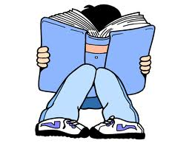
Reading Records & Assessing Reading

Assessing Reading

How you can help…
Comments in reading records can provide excellent evidence that your child is meeting a specific focus in their reading. This can contribute to our assessment records in school and help to make an overall judgement of your child's reading ability.

This leaflet is designed to help guide you in the types of comments that are useful in school.

The skills for reading have been broken down into seven parts.
Here are the Assessment Foci and some suggestions of purposeful reading record comments...
Assessment Focus 1  Use a range of strategies, including accurate decoding of text, to read for  meaning.  - Can read words on sight.  - Can show awareness of punctuation marks in reading.  - Can self correct.  - Can sound words out. | Assessment Focus 2  Understand, describe, select or retrieve information, events or ideas from texts and use quotation and reference to text.  - Can recall the main ideas in a story or information text.  - Can identify how characters behave.  - Can retrieve relevant information from different paragraphs or sections.

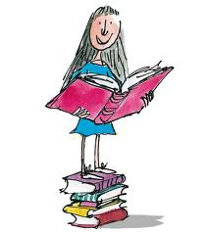

Reading Record Comments
Assessment Focus 5  Explain and comment on writers’ use of language, including grammatical and literary features at word and sentence level.  - Can comment on the effect of specific words and how they convey meaning e.g. creating atmosphere.  - Can discuss language patterns and how they contribute to the meaning e.g. repetition, or rhyming. | Assessment Focus 6  Identify and comment on writers’ purposes and view points, and the overall effect of the text on the reader.  - Can respond to the text overall and say likes and dislikes.  - Can identify the main purpose of a text, using evidence from what has been read.  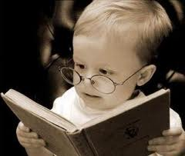

Assessment Focus 3  Deduce, infer or interpret information, events or ideas from texts and use quotation and reference to text.  - Can use knowledge of the story so far to make predictions about what will happen next.  - Can connect information together to draw out implied meaning.  - Can use clues from what characters do and say to explain their motives. | Assessment Focus 4  Identify and comment on the structure and  Organisation of texts including grammatical and presentational devices.  - Can recall the main ideas in a story or information text.  - Can identify how characters behave.  - Can retrieve relevant information from different paragraphs or sections.
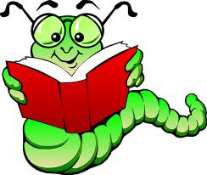
Assessment Focus 7


Relate texts to their social, cultural and historical contexts and literary traditions.

- Can identify traditional characters and settings in fiction.
Please remember that reading books are changed weekly. Please ensure your child’s reading record is signed so that we know that the book has been shared at home.
- Can relate texts to others, e.g. by the same author or a similar type.

