Helping my child to write
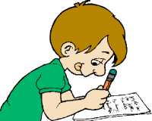

A booklet for parents

Help your child with writing

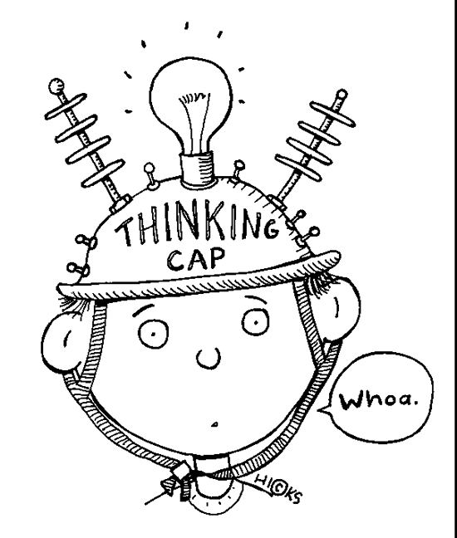
Things to know about writing
Writing is more than putting words on paper. Your child needs to think about what to write; say what they want to write, write it down and re-read their writing. It is a balancing act between having wonderful ideas (creativity), organising their ideas and the ability to put these exciting ideas onto paper (handwriting and spelling).

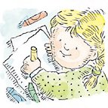
One of the first means of communication for your child is through drawing. Do encourage your child to draw and to discuss his/her drawings. Ask questions: What is the boy doing? Does the house look like ours? Can you tell a story about this picture?

As your child becomes a better writer they will need to:
- Write varied sentences, including complex sentences.
- Write sentences which are grammatically correct and punctuated.
- Organise, structure and sequence their writing.
- Use paragraphs.
- Produce writing which is imaginative, interesting and thoughtful.
- Produce writing which suits the task, the purpose and the audience.
- Use and select exciting and appropriate vocabulary
- Use correct spelling
- Develop good handwriting and present their work well.

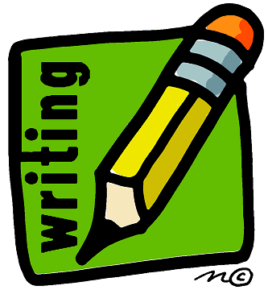
In school we teach and encourage accurate spelling and correctly formed handwriting. However, it is important to note that these are the last two items in the list. To be a good writer, the first seven points are vital. These are the focus of our writing teaching and our marking in books.
What does writing need?
Reading. Reading can stimulate your child your child’s imagination, increase their vocabulary and encourage them to write. Good writers are ‘magpies’!

If your child reads good books,
(s)he will be a better writer.

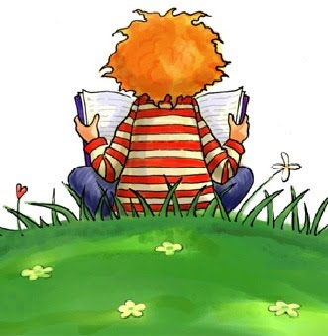
Ask children to find a "golden line" in their reading—a sentence that especially attracts them and makes them aware of what clever or colourful writing looks like.
Write interesting words on post-its!

What does writing need?

Clear thinking. Sometimes your child needs to have his/her memory refreshed about a past event in order to write about it.
Sufficient time. Children may have `stories in their heads' but need time to think them through and write them down.
A Meaningful Task. A child needs meaningful, not artificial writing tasks. You'll find suggestions for such tasks in the section, "Things to do."
Interest. All the time in the world won't help if there is nothing to write, nothing to say. Some of the reasons for writing include: sending messages, keeping records, expressing feelings, or relaying information.
Practice. And more practice.
Revising. Children need experience in revising their work – for example, seeing what they can do to make it clearer, more descriptive, more concise…

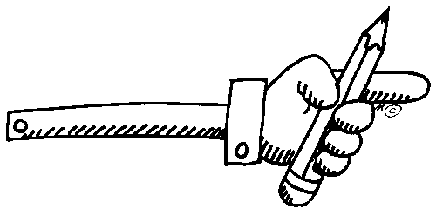
Helpful pointers for writing at home!
In helping your child to learn to write well at home, remember that your goal is to make writing easier and more enjoyable.

Provide a place: It is important for a child to have a good place to write - a desk or table with a smooth, flat surface and good lighting.

Have the materials: Provide plenty of paper - lined and unlined - and things to write with, including pencils, pens, and crayons.
Allow time: Help your child spend time thinking about a writing project or exercise. Good writers do a great deal of thinking!
Respond: Do respond to the ideas your child expresses verbally or in writing. Make it clear that you are interested in the true function of writing which is to convey ideas. This means focusing on "what" the child has written (their ideas), not "how" it was written (spelling and handwriting). It's usually wise to ignore minor errors, particularly at the stage when your child is just getting ideas together. In school, we do not correct every spelling error as this is not the main focus of the writing task.
Praise: Take a positive approach and say something good about your child's writing. Is it accurate? Descriptive? Thoughtful? Interesting? Does it say something?
Write together: Encourage your child to help you with letters, even routine ones, such as ordering from an advert! It is important that your child sees that writing is important to adults.

Things to do!

- Exchange Post-it notes with your children. Put the notes on pillowcases or lunch boxes or any surprise location!
- Help your child assemble photo albums of family events and write captions.
- Ask children to put their wishes and wants into writing and suggest how they may work toward or contribute to getting what they want.
- Help your child create a family newsletter or website to share with family members near and far.
- Suggest that your children write postcards to themselves when they are away from home. When they receive their own postcards in the post, they will have a souvenir of their trip.
- Make writing practical and useful by having children write grocery and task lists, reminders and phone messages, instructions for caring for pets, or directions for getting to the park.
- Encourage your child to keep a diary.
- Suggest note-taking on trips or outings.
- Use games to help increase your child’s vocabulary. Try crossword puzzles, word games, anagrams…
- Encourage your child to write to relatives and friends (or maybe a pen-pal).

