**Literacy**

Traditional tales – new versions.

Recounts – diary of fire, newspaper of Florence.

Charlies Superhero Underpants.

**Famous Faces.**

**Florence Nightingale and Samuel Pepys**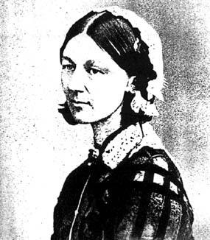 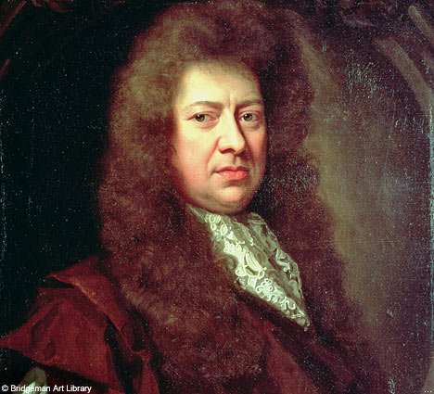

**PE**

Gymnastics – using different body parts

**RE**

Special People

Good and evil

Meals

Jewish customs and beliefs.

**Science-** Health and Growth

Labelling parts of the body-

How body develops with age

Healthy eating/balanced meal-

Fitness- importance of exercise.

Visiting the doctor if ill- safety of medicines.

Life Cycles

Teeth and hygiene.

**History-** Links to chronological texts

* To make a time line
* To sequence events
* To discuss what we would like to know about historical events and people.
* To ask questions why, when, how, where
* To search for information and facts using internet, books, videos
* To discuss features of Chronological text.
* (TA)- to write chronological report- (LA)- to find facts and record as bullet points.
* Read extracts from Samuel Pepys diary on [www.bbc.co.uk/famouspeople-](http://www.bbc.co.uk/famouspeople-) to develop own code
* Learn a fire poem off by heart and write own poem
* ~Compose compound words using the word ‘fire’ as a starting point
* ~Finish sentence starters about the Great Fire(LA)
* To write a report for London Gazette (TA)
* To write what they imagine it would be like to be a soldier/nurse in Florence’s time.

**Maths-**

Timeline- years

Ordering time events

Using stop watch for pulse/fitness

Grouping food groups – venn and carroll diagrams.

3d shapes – food packaging

Multiplication and division – related facts.

**Art/DT-**

Explore colour-mixing ‘hot; colours

~Painting silhouette pictures using ‘hot’ colours and black paper

~Creating a ‘life-size’ fire-fighter in uniform using children as templates

Make 3d fire engines

Make black and white houses

**Computing**

Using the internet for research purposes to find out about the lives and works of various famous people.

**Geography/History**

To look at maps to see where Florence was born and worked.

To look at maps of London and where fire took place

To look at pictures and films from the past

Visit black and white house.

Visit from fire officers- talk on safety

**Thinking Skills-**

To be able to compare and contrast life now and in the past.

To think of ways to find information and look for evidence.

~Decision making and asking more focused questions