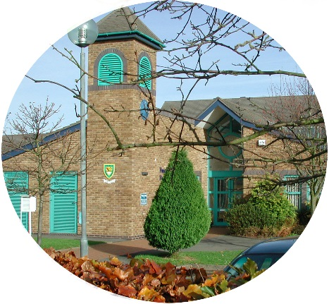
FINSTALL FIRST SCHOOL
Carnforth Road
BROMSGROVE
Worcestershire
B60 2HS
Tel: 01527 872938
E-mail office@finstallfirst.co.uk
Web Site www.finstallfirst.co.uk

HEADTEACHER: Mr Stuart Evans
Learning Together, Preparing for Life

Friday 8th March 2024

Dear Parents,

School Meal Order Forms

Please find attached, the forms for ordering School Dinners for the first half of the Summer Term 2024. Please complete the form, which covers 8th April to 24th May 2024, and return to your child’s class teacher or email office@finstallfirst.co.uk as soon as possible and by no later than Friday 15th March.

If you do not require any lunches this term please could you tick the box on the top left-hand side of the form and return it to the class teacher or the school office.

Before completing the form, please be aware that you will be ordering from a new menu, which is attached and can also be found on the School’s Website following the tabs for ‘Information’ and ‘Class Catering’.

Please note Years Two, Three and Four have trips this half term and will not be in school when hot lunches are served. However, either ham or cheese sandwiches can be ordered from Class Catering as a packed lunch on these days.

Thank you in anticipation of receiving your support with the ordering of lunches.

Yours sincerely,

Stuart Evans
Head Teacher

