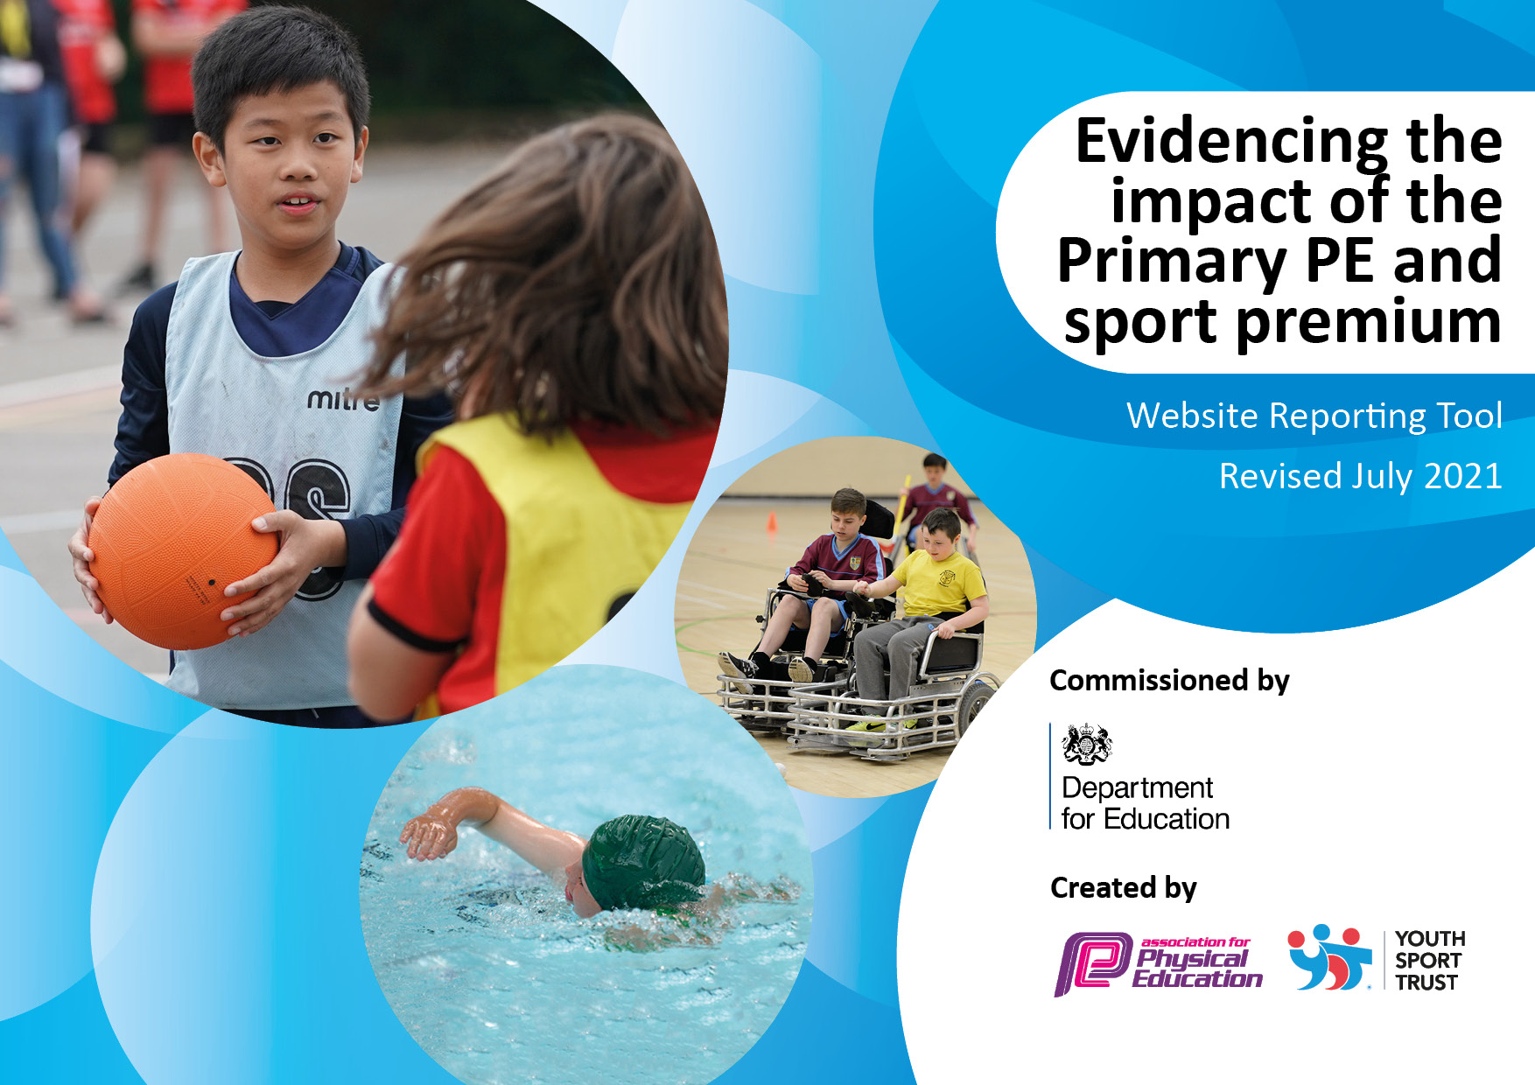
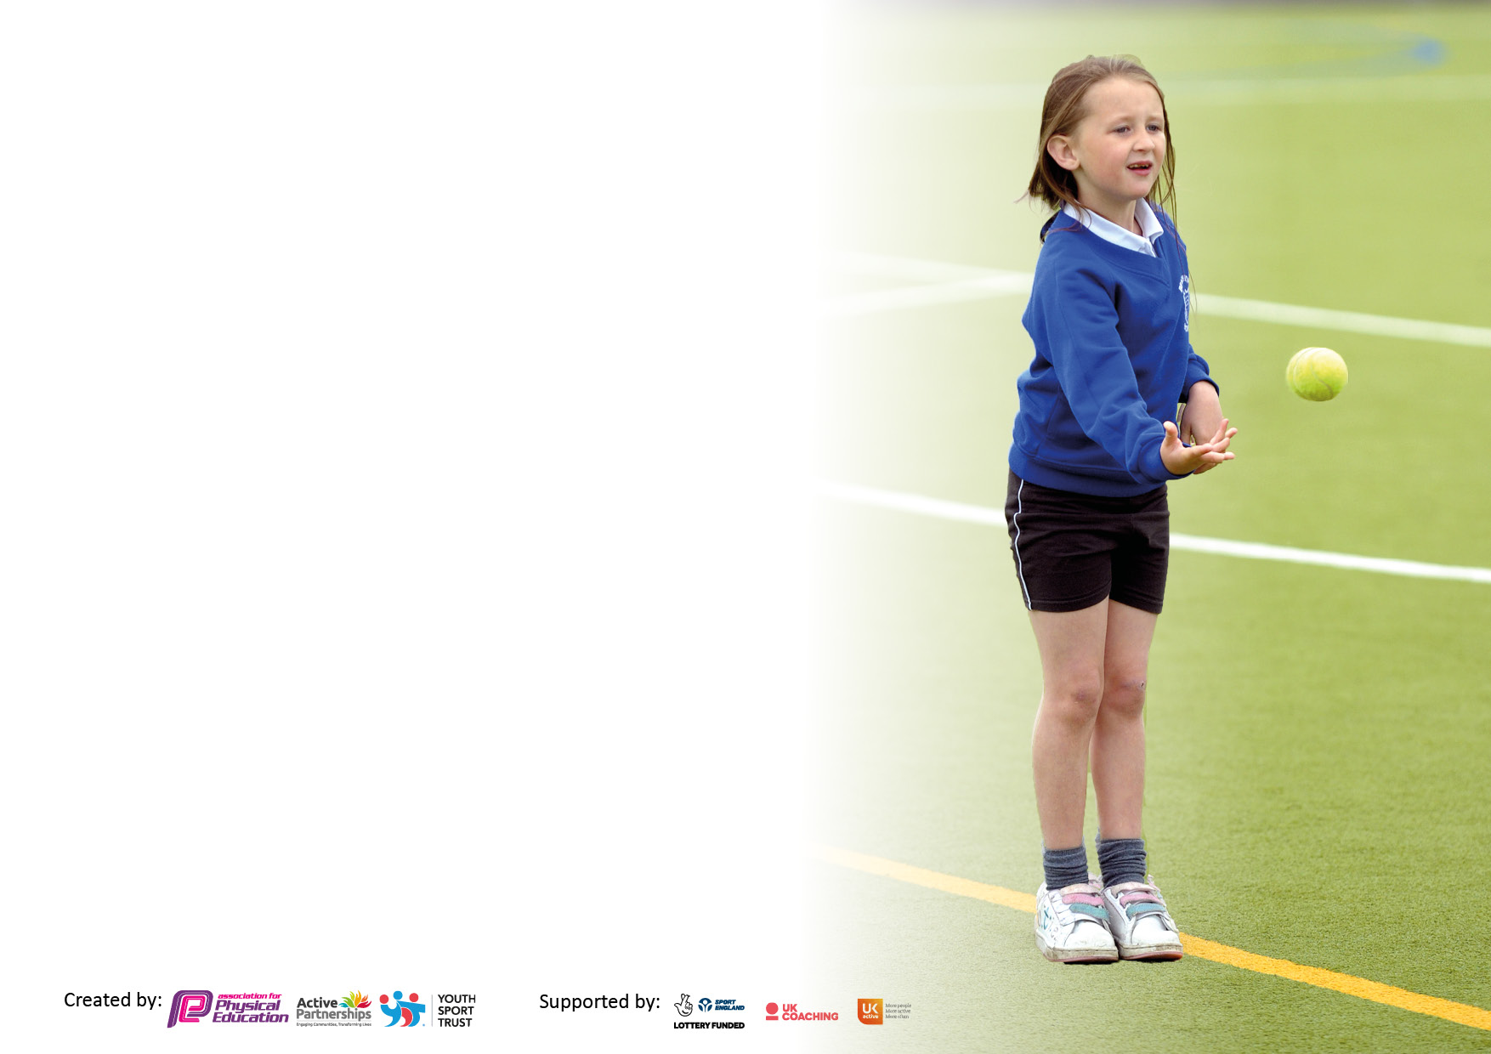

It is important that your grant is used effectively and based on school need. The Education Inspection Framework makes clear there will be a focus on ‘whether leaders and those responsible for governors all understand their respective roles and perform these in a way that enhances the effectiveness of the school’.

Under the Quality of Education Ofsted inspectors consider:
Intent - Curriculum design, coverage and appropriateness
Implementation - Curriculum delivery, Teaching (pedagogy) and Assessment
Impact - Attainment and progress

To assist schools with common transferable language this template has been developed to utilise the same three headings which should make your plans easily transferable between working documents.

Schools must use the funding to make additional and sustainable improvements to the quality of Physical Education, School Sport and Physical Activity (PESSPA) they offer. This means that you should use the Primary PE and sport premium to:

- Develop or add to the PESSPA activities that your school already offer
- Build capacity and capability within the school to ensure that improvements made now will benefit pupils joining the school in future years
- The Primary PE and Sport Premium should not be used to fund capital spend projects; the school’s budget should fund these.

Please visit gov.uk for the revised DfE guidance including the 5 key indicators across which schools should demonstrate an improvement. This document will help you to review your provision and to report your spend. DfE encourages schools to use this template as an effective way of meeting the reporting requirements of the Primary PE and sport premium.
We recommend you start by reflecting on the impact of current provision and reviewing the previous spend.

Schools are required to publish details of how they spend this funding, including any under-spend from 2019/2020, as well as on the impact it has on pupils’ PE and sport participation and attainment. All funding must be spent by 31st July 2022.

We recommend regularly updating the table and publishing it on your website throughout the year. This evidences your ongoing self-evaluation of how you are using the funding to secure maximum, sustainable impact. Final copy must be posted on your website by the end of the academic year and no later than the 31st July 2021. To see an example of how to complete the table please click HERE.

Details with regard to funding
Please complete the table below.

Total amount carried over from 2020/2021 | £0.00 left but overspend of £1,119
Total amount allocated for 2021/22 | £18,400 but £17,281 when over expenditure taken off.
How much (if any) do you intend to carry over from this total fund into 2022/23? | £0.00
Total amount allocated for 2022/23 | £18,400
Total amount of funding for 2022/23. To be spent and reported on by 31st July 2023. | £18,400
Swimming Data
Please report on your Swimming Data below.

Meeting national curriculum requirements for swimming and water safety.
N.B. Complete this section to your best ability. For example, you might have practised safe self-rescue techniques on dry land which you can then transfer to the pool when school swimming restarts.
Due to exceptional circumstances priority should be given to ensuring that pupils can perform safe self-rescue even if they do not fully meet the first two requirements of the NC programme of study
What percentage of your current Year 6 cohort swim competently, confidently and proficiently over a distance of at least 25 metres?  N.B. Even though your pupils may swim in another year please report on their attainment on leaving primary school at the end of the summer term 2022. Please see note above | N/A – No Yr 6 pupils  End of Yr 4 – 71% of 59 pupils
What percentage of your current Year 6 cohort use a range of strokes effectively [for example, front crawl, backstroke and breaststroke]?  Please see note above | N/A – No Yr 6 pupils  End of Yr 4 – 71% of 59 pupils
What percentage of your current Year 6 cohort perform safe self-rescue in different water-based situations? | N/A – No Yr 6 pupils  End of Yr 4 – 71% of 59 pupils
Schools can choose to use the Primary PE and sport premium to provide additional provision for swimming but this must be for activity over and above the national curriculum requirements. Have you used it in this way? | Yes

Action Plan and Budget Tracking
Capture your intended annual spend against the 5 key indicators. Clarify the success criteria and evidence of impact that you intend to measure to evaluate for pupils today and for the future.

Academic Year: 2021/22 | Total fund allocated: £17,281 | Date Updated: 21.07.22
Key indicator 1: The engagement of all pupils in regular physical activity – Chief Medical Officers guidelines recommend that primary school pupils undertake at least 30 minutes of physical activity a day in school |  |  |  | Percentage of total allocation:
 |  |  |  | 49%
Intent | Implementation |  | Impact
Your school focus should be clear what you want the pupils to know and be able to do and about  what they need to learn and to  consolidate through practice: | Make sure your actions to achieve are linked to your intentions: | Funding allocated: | Evidence of impact: what do pupils now know and what can they now do? What has changed?: | Sustainability and suggested next steps:
Highlighting the importance of being active throughout the day, especially during breaktimes and lunchtimes.  To ensure the children have the opportunity to be physically active for at least 30 mins of each day in school and to encourage 30 mins outside of school hours.  To encourage pupils to be physically active during Maths lessons.  To provide a wider range of sporting activities and access to competitive sport for our children. To provide additional training to staff and Sport / Play Leaders so they can continue to deliver sessions / encourage activity at play times.  To increase pupil participation in sporting activities.  To raise awareness of the benefits of sport and to spark an interest in a sport they could participate in outside of School.  To increase participation in sport of disadvantaged children.  To carry out an audit of equipment, tidy and reorganise various sheds so that equipment is well-placed for lessons and play time activities. | Re-development / repairs to the adventure playground and climbing wall so that children can utilise this equipment during playtimes / lunch times.  Boards to display Breaktime Challenges promoting being ‘active’.  Staff / pupils log-in to Teach Active to provided more activity in Maths lessons.  Jumping Jaxx Resource purchase to support play-leading at breaktimes.  Subscription to All Active Academy  Access a wide range of After-School Clubs and sports tournaments and festivals to allow more children to be active throughout the day.  Hold School Sports week, during which children are introduced to different sports and can find out how they can access and participate in such sports outside of School. Close links with sports / activity clubs in the local Community.  Attend Pupil Premium Sports Event run by the All Active Academy.  Complete audit, tidy and reorganise equipment into appropriate sheds. | £3,500  £160.80- display boards  £605- Teach Active  £25 Jumping Jaxx Resource  £2178- All Active Academy  £1,046 - After School Clubs  Sports Week Cost –  £511.25  Transport for coaches / minibus  (Included in  KI 5)  Cost of additional staff time - £500 | Evidence  - Breaktime Challenge Sheets  - Timetable for Breaktimes  - Sports Week Timetable  - Weekly Plans for Maths  - All Active Academy Calendar  - Jumping Jaxx Folder  - After School Club Lists  Impact  Each year group has had the opportunity to go on different parts of the playground equipment during breaks and lunchtimes. They are time-tabled to use different activities throughout the week. Sports Crew are running challenges on different sections of the playground to encourage more children to be active/mindful during their breaks. These also linked to ‘Fabulously Fit at Finstall’ challenges so children can practice these skills in school.  Staff have incorporated lots of ‘active’ starters into their Maths sessions this year using the ideas on the website.  This resource allowed us to provide the play / sport leaders with new ideas for play leader games. Therefore, at break times, children were able to be more active when taking part in the playleader games provided. Our playleaders were also trained to use this resource using a trainer provided by the ‘All Active Academy’.  As part of our subscription to the ‘All Active Academy’ they have provided active sessions every half term. Staff around the school, when possible, would log onto these with their class to have active learning breaks.  Pupils have also had access to a wide range of sporting activities and competitive sport opportunities. Over this year, we have provided a range of clubs for all of our year groups. Over 60% of the children in our school have been offered a club this year, as we have strived to get as many children active during each day as possible after the impact that covid had on our children.  The children in each year group were provided with a range of different sports during sports week which the children really enjoyed. Lots of children commented at the end of sessions that they would like to take some of these sports up. Leaflets were given out from some sessions to promote clubs in the local area.  Disadvantaged children were able to take part in an event where they could be inspired to understand the importance of physical activity on their lifestyle promoting being active outside of school.  Equipment audited, tidied and reorganised into most appropriate sheds for easy access to equipment for PE lessons / break and lunch times. | Continue to utilise sports crew to encourage children to use the equipment provided at breaks and lunchtime to promote physical activity to ensure children are exercising for at least 30 minutes a day. As part of their role as sports crew, get the children to analyse who is/isn’t taking part in challenges to decide on a strategy of how to get children involved.  To continue to develop the ‘Fabulously Fit at Finstall’ initiative to get more children active at home each term.  To train up new sports leaders next year to utilise the ‘Jumping Jaxx’ folder further.  Continue to allow staff access to Teach-Active to embed even more active starters into their Maths lessons.  Continue to encourage Play Leaders to make use of this resource.  To continue our subscription to All Active Academy and use some of our CPD hours to train up new play / sports leaders.  Continue with active sessions each half term.  To utilise our hall timetable to its maximum potential for after-school clubs to run to be able to offer even more children the opportunity to take part in an extra-curricular club.  To continue to offer alternative sports during school sports week next year and to continue to create strong links with local clubs that can help to promote active lifestyles outside of School.  Continue to offer disadvantaged children the chance to take part in sporting activities run by the All Active Academy.  Maintain tidiness of equipment so it is well organised and easily accessible for all. Make use of Sports Crew for this task.
Key indicator 2: The profile of PESSPA being raised across the school as a tool for whole school improvement |  |  |  | Percentage of total allocation:
 |  |  |  | 14%
Intent | Implementation |  | Impact
Your school focus should be clear what you want the pupils to know and be able to do and about  what they need to learn and to  consolidate through practice: | Make sure your actions to achieve are linked to your intentions: | Funding allocated: | Evidence of impact: what do pupils now know and what can they now do? What has changed?: | Sustainability and suggested next steps:
To continue to develop the PE curriculum across the school, ensuring strong sequencing of learning and effective progression of skills, knowledge and vocabulary as children move through the School.  To continue to ensure children of all abilities are engaged and motivated by PE and sport, both inside and outside of lesson time. | Continue to work closely with cluster schools through the meetings provided by All Active Academy.  Adapt and improve curriculum, sequences of learning and progression maps.  Additional time for PE Lead to develop the curriculum and monitor the delivery and impact of PE lessons ensuring that lessons are engaging and enjoyable. | £2,178 - subscription to All Active Academy -included in KI 1.  Supply cover for meetings - £400  Additional curriculum development and monitoring time for PE Lead -£1,890.48 | Evidence  - Year 2 Planning  - Year 4 Planning  - PE Progression Maps  Impact  PE Coordinator has attended regular meetings either via zoom or at Bromsgrove School where discussions have been had about sequences of learning, progression maps, competitions and future training needs, which have led to improvements in sequencing and progression in our PE curriculum – e.g. New units for Year 2 and Year 4 created and used by staff this year, which has improved progression across the School.  Additional monitoring has led to improvements in the delivery of lessons and enabled PE lead to identify future training needs and resource issues. Lessons are more engaging and enjoyable for pupils. | Continue the strong links between schools by being a part of the ‘All Active Academy’ again next year.  To continue to develop the PE curriculum by using the CPD hours from the ‘All Active Academy’ and additional time provided for developing the curriculum and monitoring its impact.  To continue to monitor, adapt and improve planning where necessary, offering support, training and resources to staff where required.

Key indicator 3: Increased confidence, knowledge and skills of all staff in teaching PE and sport |  |  |  | Percentage of total allocation:
 |  |  |  | 6%
Intent | Implementation |  | Impact
Your school focus should be clear | Make sure your actions to | Funding | Evidence of impact: what do | Sustainability and suggested
what you want the pupils to know | achieve are linked to your | allocated: | pupils now know and what | next steps:
and be able to do and about | intentions: |  | can they now do? What has
what they need to learn and to |  |  | changed?:
consolidate through practice:
To ensure staff are able and capable of teaching all areas of PE and games to a good or better level. | Analyse the PE Assessment Data from this year to monitor the attainment of pupils and, in particular, the impact of the ‘Deeper Understanding’ statements.  Identify any inconsistencies in the data and any areas of relative weakness.  Additional time for PE Lead to monitor the delivery and impact of PE lessons.  Teacher questionnaire to be given out at the start of the year to gain an understanding of any CPD requirements so that we can continue to develop staff’s subject knowledge and confidence and identify gaps in resources/ equipment and purchase according to priority.  Staff provided with training on how to use the new planning provided for Year 2 multi-skills lessons. | Additional curriculum development and monitoring time for PE Lead – included in KI 2  £1,044.98 Equipment / Resources purchased  £2,178 - subscription to All Active Academy -included in KI 1 | Evidence  - Foundation Subject Assessment  - Subject Analysis  - Teacher Questionnaire  - Year 2 Planning  - Year 4 Planning  - Progression Maps  - Regular professional conversations with staff teaching new units.  Impact  High % of pupils attaining a good level of understanding in PE and a reasonably high % attaining a deep level of understanding. Specific areas identified where performance was not as high. Interviews with staff to take place to identify reasons – additional support / training to be offered as required.  Staff are using the new ‘drop down’ option to help with their judgements of children who are attaining a deeper level of understanding. This has helped them to make such judgements with increased confidence.  After the Questionnaire to staff was analysed, no staff at the current time requested CPD but some asked for more equipment to be bought. Staff were frequently offered training for different sports e.g. gymnastics, dance, mindfulness. But none took it up this time. Therefore, equipment was bought as requested. Reception in particular requested new equipment to help to deliver the physical development aspect within the new EYFS curriculum. E.g. a basketball stand and balls, allowing the children to develop their hand-eye co-ordination, gross motor and ball skills. They also needed a new shed to store the additional equipment in.  Staff in Year 2 were given time to read through new plans and share ideas on how best to achieve the new objectives. The PE coordinator supported them with this to help aid their confidence to teach the new units, allowing them to teach high quality lessons.  Improved sequence of learning and improved progression led to improved outcomes for Year 2. | Continue with ongoing analysis of assessment information, offering support, training and resources to staff where required.  To continue to monitor, adapt and improve planning and delivery where necessary, offering support, training and resources to staff where required.  To complete another annual staff questionnaire to elicit any further training, support, resources, etc. needed for next year.  Send new member of staff on ECT PE course offered by the All Active Academy.  Offer staff training on new alternative sports.  To continue our subscription to the All Active Academy to utilise our CPD hours to provide training to staff on any new planning brought in, especially for alternative sports.
Key indicator 4: Broader experience of a range of sports and activities offered to all pupils |  |  |  | Percentage of total allocation:
 |  |  |  | 30%
Intent | Implementation |  | Impact
Your school focus should be clear | Make sure your actions to | Funding | Evidence of impact: what do | Sustainability and suggested
what you want the pupils to know | achieve are linked to your | allocated: | pupils now know and what | next steps:
and be able to do and about | intentions: |  | can they now do? What has
what they need to learn and to |  |  | changed?:
consolidate through practice:
To continue to ensure children of all abilities are engaged and motivated by PE and games inside and outside of lesson time.  To ensure that all Year 4 children experience high quality OAA activities as part of a residential visit.  To ensure all Year 4 children had the opportunity to take part in bell-boating- a safe way to introduce pupils to water sports.  To introduce children to a range of alternative sports.  To provide children with opportunities to participate in competitive sports.  To provide children with opportunities to participate in a wide range of after school clubs.  To provide opportunities for children in Years 3 and 4 to attend swimming sessions after the children in Year 4 were denied this opportunity due to Covid. | Each year group has at least 2  1-hour slots of PE each week.  Use of a playground rota to ensure all classes have access to playground equipment such as the adventure playground, bouldering wall, etc.  All the Year 4 children visited the Malvern Hills Outdoor centre where they were able to take part in high quality OAA activities.  All Year 4 children went on a ‘Bell boating Journey’ along a local canal.  Hold School Sports week, during which children are introduced to different sports and can find out how they can access and participate in such sports outside of School. Close links with sports / activity clubs in the local Community.  Participate in tournaments / festivals through All Active Academy.  After School clubs run by external coaches to be provided to offer children the opportunity to take part in a sport / activity after school.  All children in Year 4 to attend swimming for 10 weeks in the Autumn term.  All children in Year 3 to attend swimming for 10 weeks in the Spring term.  Non-swimmers from both year groups, after these sessions, to attend for a further 10 weeks in the Summer term. | Malvern trip subsidised - £999  Bell-boating subsidy - £446.66  Sports Week Cost –  £511.25 included in KI 1  £2,178 - subscription to All Active Academy -included in KI 1  Staff cover for tournaments / festivals - £900  Cost of transport - £1,225  £1,046 - After School Clubs – included in KI 1  Swimming subsidy - £1,689.27 | Evidence  - Sports Week Timetable  - Competition Lists  - After School Club Lists  - Class Timetables  Impact  All children have access to at least 2 x 1-hour lessons of physical education each week to help promote a healthy lifestyle and ensure children are meeting the requirement of 30/30 activity levels.  All children have access to a wide variety of playground equipment to promote exercise during break and lunchtimes.  All of the children in Year 4 have further developed their resilience, team work, independence, confidence and lots more whilst at Malvern, taking part in the OAA activities offered.  All the Year 4 children have been introduced to water-sports as an alternative sport by taking part in bell-boating. All children also had the opportunity to go on to do an after-school Bell-boating club at Upton Warren. A group of 20 Year 4s also took part in a Bell-boating regatta in two teams of 10. Both teams came within the top 4 boats out of 26 teams, with one of our teams winning the Regatta.  All children across school took part in a ‘Sports Week’ which provided them with the opportunity to take part in alternative sports such as Irish Dancing and Martial Arts.  A large number of children in different year groups were able to take part in a variety of different competitions and festivals, mostly organised by the All Active Academy. Lots of our children won medals at these competitions including gold medals at the Rugby and Hockey competitions.  Over this year, we have provided a range of clubs for all of our year groups. Over 60% of the children in our school have been offered a club this year, as we have strived to get as many children active during each day as possible Over this year, we have provided a range of clubs for all of our year groups.  All of the Year 4 children have had the opportunity to learn street dance routines led by an external coach to promote a love of dance. Great enjoyment from the children was shown when participating in these sessions.  All children in Years 3 and 4 attended swimming lessons for at least 10 weeks each. Then, non-swimmers from both year groups, after these sessions, attended for a further 10 weeks. | To continue to offer each year group at least 2 hours of physical education each week.  Continue to develop the use of Sports Leaders for playtimes and lunchtimes.  To continue to provide the Year 4 children with the opportunity to experience OAA as part of a residential visit.  To continue to provide the Year 4 children with the opportunity to experience a water based alternative sport - ‘Bell-boating’.  To continue to offer alternative sports during school sports week next year and to continue to create strong links with local clubs that can help to promote active lifestyles outside of School.  To include an alternative sport into more Year groups to motivate children of all abilities.  To continue to allow children to take part in competitions provided by the All Active Academy.  To maximise the opportunity for children in all year groups to attend after-school clubs.  To continue to offer Year 4 a sport in the last Summer Term provided by an external coach.  To continue to provide additional sessions for non-swimmers from Years 3 and 4 in the Summer term.

Key indicator 5: Increased participation in competitive sport |  |  |  | Percentage of total allocation:
 |  |  |  | 1%
Intent | Implementation |  | Impact
Your school focus should be clear | Make sure your actions to | Funding | Evidence of impact: what do | Sustainability and suggested
what you want the pupils to know | achieve are linked to your | allocated: | pupils now know and what | next steps:
and be able to do and about | intentions: |  | can they now do? What has
what they need to learn and to |  |  | changed?:
consolidate through practice:
To offer a range of competitive events to help to give more children the experience of competitive sport. | Continue to offer as many chances for different year groups to be involved in competitions, including those run by the All Active Academy.  Children in Upper School given the chance to compete at a Sports Day at the Ryland Centre Athletics Track.  Lower School children also participate in a competitive sports day.  Offer Level Zero competitions, run by Play / Sports leaders as part of the challenges set at break times and lunch times. | £2,178 - subscription to All Active Academy -included in KI 1  Staff cover for tournaments / festivals - £900 included in KI 4  Cost of transport - £1,225 – included in KI 4  Track Hire and Achievement Stickers - £159.56 | Evidence  - Competition Lists  - Sports Day Running Orders  - Medals and Trophies  Impact  A large number of children have had the opportunity to take part in competitions outside of school such as Football, Hockey, Tennis, Rugby, Tri-golf, Bell-boating etc. where they have competed against other teams from other schools in the area promoting the competitive side of team games.  3 teams of children from Year 3 and 4 have qualified to compete in regional competitions. A group of Year 4 children attended the regional Winter Sports Games for Hockey. Two groups of Year 3 children attended the regional Summer Sports Games - one team for Tennis and one team for Tri-golf.  2 of our Year 4 teams reached the ‘A’ Final of the district Bell-boating regatta where we reclaimed our ‘Paddle of Life’ trophy for coming first.  All Upper School children were able to compete in intra-sport races for Sports Day on an actual athletics track to inspire their love of athletics and competitive sport. Children were also part of a house-competition to help promote the idea of being part of a team.  Lower School children also participated in a competitive sports day – to teach them about winning and losing gracefully, sportsmanship, etc. - although the events are more low key.  At break and lunchtimes children were able to take part in challenges to beat their personal bests. | To continue to provide children with plentiful opportunities to take part in competitions, including those organised provided by the All Active Academy in the hope that some will progress to the regional finals.  To reintroduce competitive sports between houses within our School – possibly as part of School Sports Week.  To maintain the Upper School and Lower School Sports Days in their current form.

Signed off by
Head Teacher: | Stuart Evans
Date: | 21.7.22
Subject Leader: | Sophie Law
Date: | 21.7.22
Governor: | Rebecca Miles
Date: | 21.7.22

